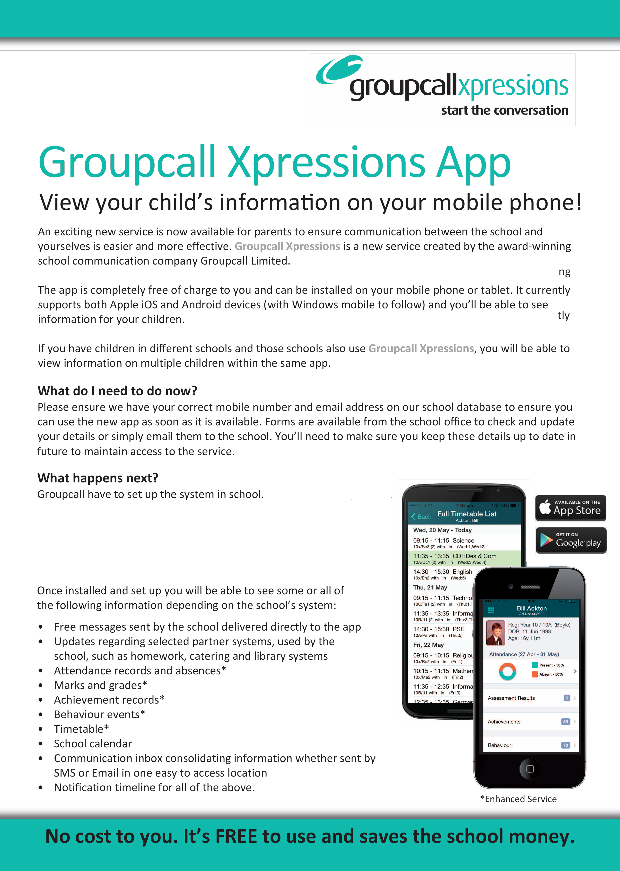

Once that is complete you can download the app from your respective app store and sign in using the same email address and mobile number you supplied to the school. If you have not supplied the school with a current email address and mobile number, you cannot use the Xpressions app - contact your school to update these.

