Your Ref:
Our Ref: ES/SP
Contact: Eleanor Sheppard
Location: Marischal College

Date: 19 August 2020

Dear parent/carer

SQA Appeals

The Scottish Qualifications Authority (SQA) has issued more detailed guidance on the appeals process for 2020.

This process allows only three grounds upon which a school can submit an appeal:

- If a school discovers that an administrative error was made when they submitted their estimate or entry information for a candidate.

- If a school’s internal review process discloses that a candidate’s estimate was affected by discrimination or other conduct by the school that is unacceptable under the Equality Act 2010.

- Where a head teacher believes that there has been an error within SQA’s internal processes for confirming results to schools following the 11 August announcement, they can also appeal.

Aberdeen City Council anticipates that only in exceptional circumstances will such appeals arise given the robust quality assurance processes undertaken by schools in advance of submiting estimated grades. Schools will contact you directly if they believe any of the grounds apply and can be evidenced.

Parents and young people will not be able to appeal against the estimate given by the school.

Thank you for your continued support.

Yours sincerely

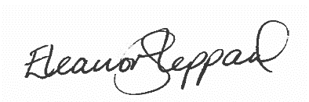

Eleanor Sheppard
Chief Education Officer

