Aberdeen
City Campus
Course Choice 2020/21

Please note: with recent changes to SQA exams, some of the assessment information may not be correct. Please check with your school.

07.01.20
INDEX
Course | SCQF Level | Qualification/Award | Providing Partner | Venue | Page
Accounting | 6 | Higher | ACC | AGS | 4
Biology | 7 | Advanced Higher | ACC | AGS | 5
Chemistry | 7 | Advanced Higher | ACC | St. Machar | 6
Chemistry | 6 | Higher | ACC | St. Machar | 7
Computing Science | 6 | Higher | ACC | AGS | 8
Dance | 6 | Higher | Citymoves | Citymoves Studio | 9
Drama | 7 | Advanced Higher | ACC | AGS | 10
English | 7 | Advanced Higher | ACC | AGS | 11
ESOL (English for Speakers of Other Languages) | 5 | National 5 / Higher | ACC - EAL Service | Harlaw | 12
French | 7 | Advanced Higher | ACC | Hazlehead | 13
French | 6 | Higher | ACC | Hazlehead | 14
Gaelic | 4/5 | National 4/5 learners | ACC | Hazlehead | 15
Geography | 7 | Advanced Higher | ACC | AGS | 16
German | 6 | Higher | ACC | Hazlehead | 17
History | 7 | Advanced Higher | ACC | AGS | 18
Mandarin | 7 | Advanced Higher | ACC | Oldmachar | 19
Mandarin | 6 | Higher | ACC | Oldmachar | 20
Mandarin | 4/5 | National 4/5 | ACC | Oldmachar | 21
Mathematics of Mechanics | 7 | Advanced Higher | ACC | Harlaw | 22
Modern Studies | 7 | Advanced Higher | ACC | AGS | 23
Moving Image Arts | 6 | AS Level | SHMU | SHMU | 24
Physics | 7 | Advanced Higher | ACC | AGS or Harlaw | 25

Course locations & bus routes are on pages 25 onwards.

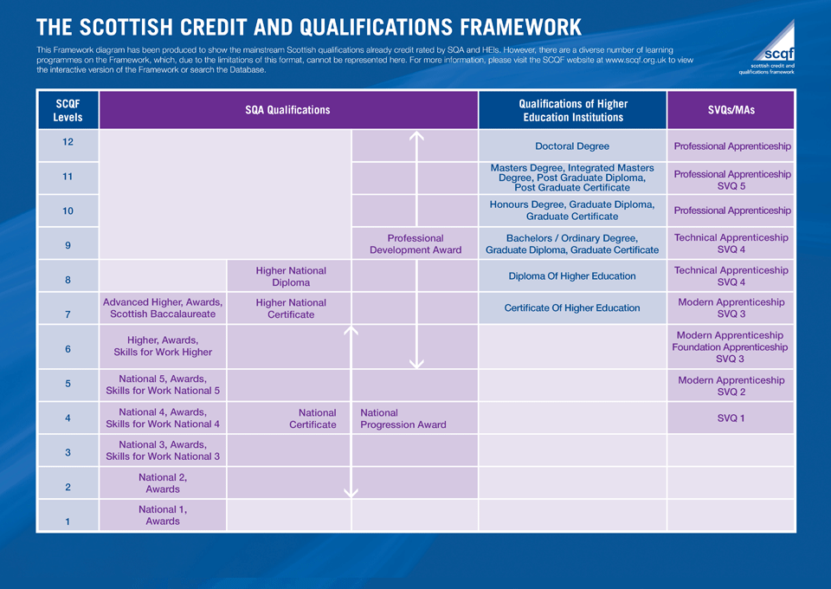

Courses

ACCOUNTING HIGHER
SCQF 6
Days | Tue/Thurs 2-4pm
Location | Aberdeen Grammar School
Starting Date | Mon8th June / Tue 9th June
Entry Requirements | National 5 Maths or National 5 Accounting
Course Content | The Course has three mandatory Units:  Preparing Financial Information (Partnership and PLC accounts),  Preparing Management Information (Budgeting and Costing) and  Analysing Accounting Information (Ratios and Decision-making).
Career progression | Further Education or Higher Education e.g. HNC/D or degree courses in Accounting and Finance, Business or Management studies  A range of employment – Insurance, Banking, Accounting, Administration jobs
Materials Required | The school provides all materials for all courses, the pupils don’t need to bring anything apart from a ruler and a calculator.

BIOLOGY ADVANCED HIGHER
SCQF 7
Days | Mon/Wed 2-4pm
Location | Aberdeen Grammar School
Starting Date | Mon 8th June
Entry Requirements | A Higher Biology or Human Biology pass at A or B is desired. Entrance to the course is at the discretion of the department.
Course Content | This course is composed of the following 3 Units:  - Cells and Proteins: proteomics, protein structure, binding and conformational change; membrane proteins; detecting and amplifying a stimulus; communication within multicellular organism and protein control of cell division. The Unit includes important laboratory techniques for biologists.  - Organisms and Evolution: evolution; variation and sexual reproduction; sex and behaviour and parasitism. This Unit covers techniques for ecological field study.  Investigative Biology: This Unit builds on understanding of the scientific method from Higher Biology. Learners will develop knowledge and understanding of the principles and practice of investigative biology and its communication. The Unit covers scientific principles and processes, experimentation and critical evaluation of biological research.
Assessment | To gain the award of the Course, the learner must pass Course assessment. Course assessment will provide the basis for grading attainment in the Course award at levels A-D. The Course assessment is externally assessed and composed of the following two components:  - Component 1 — question paper 100 marks  - Component 2 — project 30 marks
Materials Required | Access to Scholar is expected and the Bright Red Advanced Higher book is recommended.

CHEMISTRY ADVANCED HIGHER
SCQF 7
Days | Tue/Thur
Location | St. Machar Academy
Starting Date | Tue 9th June
Entry Requirements | A Higher Chemistry pass at A or B is desired. Entrance to the course is at the discretion of the department.
Course Content | The course is comprised of three units:  - Inorganic and Physical Chemistry  - Organic Chemistry and Instrumental Analysis  - Researching Chemistry  Study at this level builds on previous knowledge and understanding of the physical and natural environments. Throughout the course, concepts which have been introduced in the Higher course are developed, leading to deeper and broader understanding. The range of practical skills is also developed with many new techniques being introduced. The course also develops the skills of independent study and thought – particularly during the individual research project. The course is particularly suitable for candidates who wish to progress to degree courses either in chemistry or in subjects in which chemistry is a major component such as medicine, chemical engineering, and the environmental and health sciences.
Assessment | The externally assessed parts of the course are a written paper, worth 100 marks and a project worth 30 marks.
Materials Required

CHEMISTRY HIGHER
SCQF 6
Days | Tue/Thur
Location | St. Machar Academy
Starting Date | Tue 9th June
Entry Requirements | A National 5 Chemistry pass at A or B is desired. Entrance to the course is at the discretion of the department.
Course Content | There are four units:  - Chemical changes and structure – controlling reaction rates & periodic trends; collision theory & the use of catalysts in reactions; electro-negativity and intra-molecular and intermolecular forces.  - Researching Chemistry – relevance of chemical theory to everyday life by exploring the chemistry behind a topical issue.  - Nature’s Chemistry – Organic chemistry within the context of the chemistry of food and the chemistry of everyday consumer products, soaps, detergents, fragrances and skincare.  - Chemistry in Society – the principles of physical chemistry which allows a chemical process to be taken from the researcher’s bench through to industrial production.
Assessment | The Course assessment will consist of two Components: a question paper and an assignment.  Component 1 — question paper.  The question paper will have 100 marks The question paper will have two Sections. Section 1 (Objective Test) will have 20 marks. Section 2 will contain restricted and extended response questions and will have 80 marks.  Component 2 — assignment  This assignment requires learners to apply skills, knowledge and understanding to investigate a relevant topic in chemistry. The topic should draw on one or more of the key areas of the Course, and should be chosen with guidance from the assessor. The assignment will have 20 marks.
Materials Required

COMPUTING SCIENCE HIGHER
SCQF 6
Days | Mon/Wed 2-4pm
Location | Aberdeen Grammar School
Starting Date | Mon 8th June
Entry Requirements | Pupils wishing to participate in this course should have achieved a pass at N5 Computing or evidence of an interest in computing and N5 pass in a related technology subject.
Course Content | The Course enables learners to develop an extended range of computing and computational thinking skills, including skills in analysis and problem-solving, design and modelling, developing, implementing, testing and evaluating digital solutions across a range of contemporary contexts.  The Course has two mandatory Units: Software Design and Development (Computational constructs, Data types and structures, Testing and documenting solutions, Algorithm specification) and Information System Design and Development (Database and Web based structures, Media types, Coding and testing).
Assessment | The learner will be assessed by a combination of a question paper worth 90 marks and an assignment worth 60 marks. Learners will apply knowledge and skills to solve an appropriately challenging computing science problem. The question paper introduces breadth to the assessment.
Materials Required

DANCE HIGHER
SCQF 6
Days | Mon/Wed
Location | Citymoves Studio, Schoolhill (Above the Triplekirks)
Starting Date | Mon 8th June
Entry Requirements | Higher Dance accepts all students from 5th and 6th year. Previous dance or drama experience is preferable.
Course Content | Technical Skills Unit  - Develop and apply skills in two contrasting techniques. These will be Contemporary and Jazz.  - Research key practitioners and historical context influencing these two distinct styles.  Choreography Unit  - Create a group piece of choreography that communicates their chosen theme.
Assessment | Component 1 — Performance (70 marks)  Candidates will perform two tutor-choreographed technical solos, each lasting between 1.5 and 2 minutes, and each worth 35 marks.  Component 2 — Practical Activity (70 marks)  This component has two Sections.  Section 1: Choreography will have 35 marks. In this Section, candidates create and present a choreography for a group of dancers (excluding self), lasting between 2 and 3 minutes.  Section 2: Choreography Review will have 35 marks. In this Section, candidates review their work as a choreographer by explaining the relationship between their research, theme and an initial motif, explaining the reasons for the choreographic choices made, and reflecting on their skills as a choreographer.

DRAMA ADVANCED HIGHER
SCQF 7
Days | Mon/Wed 2-4pm
Location | Aberdeen Grammar School
Starting Date | Mon 9th June
Entry Requirements | A Higher Drama and Higher English pass at A or B is desired. Entrance to the course is at the discretion of the department.
Course Content | This course consists of two core units as well as a practical examination and a written project. Although the unit titles are the same as Higher there is a focus on Theatre Practitioners and their impact on modern theatre. Students will be required to analyse the influences, theories and practice of these practitioners.  Drama Skills  In this Unit, learners will be required to provide evidence to demonstrate their knowledge and skills in devising, directing and performing through the exploration of a key practitioner. They will independently create a devised drama production, using their dramatic interpretation of complex texts. They will present it to an audience and evaluate their effectiveness as an actor or director.  Production Skills  In this Unit, learners will focus on a study of a key theatre practitioner, and explore in depth the influences on and the theory and practice of their chosen practitioner. They will explore and analyse key productions that reflect their acting or directing or design methodologies through both research and practical experimentation. They will also view and analyse a live theatrical event, considering performance concepts and effectiveness.
Assessment | Component 1 — Practical Exam  The practical exam will have 60 marks (60% of the total mark). The practical exam has two sections.  - Section 1 will have 50 marks. (For performance in the chosen role of acting, directing or design)  - Section 2 will have 10 marks. (These marks are awarded for a report based on their chosen role and production)  Component 2 — Project  The project will have 40 marks (40% of the total mark).  - The candidate will select a topic from relevant and current performance theories and practice. The project will consist of a written response consisting of a 3000 word dissertation which is marked externally.  Total 100 Marks
Materials Required | No materials are required.

ENGLISH ADVANCED HIGHER
SCQF 7
Days | Tue/Thur 2-4pm
Location | Aberdeen Grammar School
Starting Date | Tue 9th June
Entry Requirements | A Higher English pass at A or B is desired. Entrance to the course is at the discretion of the department.
Course Content | The Advanced Higher English course is comprised of two units:  - English: Analysis and Evaluation  Learners will provide evidence of their ability to critically respond to previously studied complex and sophisticated texts, and of their ability to carry out an independent study into an aspect or aspects of literature.  - English: Creation and Production  Learners will provide evidence of their writing skills through the production of writing which demonstrates a range of skills necessary for the deployment of language to create effect.
Assessment | Internal assessments will be carried out under controlled conditions and assessed on a pass/ fail basis. If any internal unit is failed, pupils will be given an opportunity to revise their work, following feedback from their teacher.  The course will be graded A-D by the external assessment of:  - A two part portfolio – total 60%  Part A: Dissertation – 30%  Part B: Writing – 30%  (comprising two pieces of original writing)  - A two part question paper – total 40%  Part A: Literary study – 20%  Part B: Textual Analysis – 20%
Materials Required | Pen drive and selected texts may be required to be purchased.

ENGLISH FOR SPEAKERS OF OTHER LANGUAGES (ESOL) NATIONAL 5 & HIGHER
SCQF 5 & 6
Days | Tue/Thur 2-4pm
Location | EAL Service, held at Harlaw Academy
Starting Date | Tue 9th June
Entry Requirements | These qualifications are specifically for candidates whose first language is not English. Entry is by recommendation and/or initial assessment from the EAL Service. Individual circumstances will be taken into account.
Course Content | The courses develop and assess the four skills of reading, writing, speaking and listening and help you further develop independent language learning skills and strategies. You will participate in a range of activities to practise all these skills.  Both National 5 and Higher ESOL cover interesting texts and themes relevant to everyday life. You will read articles on a wide range of current affairs and topical issues from authentic sources, such as newspapers and websites.  There is a focus on developing more formal and academic English which will help you with other subjects at school and prepare you for further study at college or university and for work.  National 5 pupils are expected to understand and use detailed English language.  Higher pupils are expected to understand and use complex English language.  There is no requirement for the direct study of English literature.  The UCAS points for Higher ESOL are the same as for any other SQA Higher, including Higher English. Higher ESOL is accepted by Scottish universities as an entry qualification for most courses, instead of Higher English. If you are not sure about entry requirements for courses you are interested in, your guidance teacher can help you check with any university.
Assessment | Exam Paper 1 Listening 20%  Paper 2 Reading 25%  Paper 3 Writing 25%  In class Talking & Listening 25% 5%
Materials Required

FRENCH ADVANCED HIGHER
SCQF 7
Days | Tuesday 1.55 – 3.35pm
Location | Hazlehead Academy
Starting Date | Tue 9th June
Entry Requirements | A Higher French pass at A or B is desired. Entrance to the course is at the discretion of the department.
Course Content | The Advanced Higher French course consists of 3 units:  Understanding Language – within the contexts of Society, Learning, Employability and Culture students have the opportunity to develop and extend their reading and listening skills  Using Language – in the same four contexts students develop and extend their talking and writing skills  Specialist study – students develop and extend their planning, research and analytical skills to undertake an independent study based on literature or media.
Assessment | There will be one Unit assessment in each of the four skills (pass/fail)  The course assessment will comprise –  - A Reading and Translation paper worth 50 marks  - A Listening and Discursive writing paper worth 70 marks  - A Talking performance marked by a Visiting Examiner worth 50 marks (completed in February or March)  - A portfolio (the final product of the work done on a literary or media topic). This is worth 30 marks and is sent off to the SQA for assessment by them before the Easter break.
Materials Required | A French-English dictionary.

FRENCH HIGHER
SCQF 6
Days | Mon 1.55 – 3.35pm  Wed 1.00 - 2.45pm
Location | Hazlehead Academy
Starting Date | Tue 9th June
Entry Requirements | National 5 French at Grade A or B.
Course Content | This course builds on previous language learning skills in the development of communicative competence in French.  The course consists of two units:  - Understanding Language - developing and extending reading and listening skills in French, and developing knowledge and understanding of detailed and complex language in the contexts of society, learning, employability, and culture.  - Using Language - developing and extending talking and writing skills in French, and developing knowledge and understanding of detailed and complex language covering the same four contexts.
Assessment | To gain the award for the course, learners must pass the Course assessments. There is likely to be an extra assessment at some point in the year. We are still waiting for the nature of this to be confirmed by the SQA.  The external assessment determines the final grade for the course (A-D) and will consist of 3 parts:  - a Reading and Writing question paper (2 hours 10 minutes, worth 40 marks);  - a Listening and Writing paper (1 hour 20 minutes, worth 30 marks);  - a Talking performance worth 30 marks.  The Reading, Writing and Listening papers will be externally set and marked by the SQA, the Talking performance will be conducted, recorded and marked internally in line with SQA marking instructions and quality assured.
Materials Required | A French-English dictionary.

GAELIC
NATIONAL 5/HIGHER SCQF 5/6
BEGINNERS GAELIC SCQF 4/5
Days | N5/Higher - Mon/Wed 1.00 – 2.45pm  Beginners - Tue 1.00 - 2.45pm
Location | Hazlehead Academy
Starting Date | Mon 8th June (N5/Higher) Tue 9th June (Beginners)
Entry Requirements | Pupils would be expected to be sitting or already gained a N5 pass in another Modern Language.
Course Content | This course builds on the language learning skills developed in the Broad General Education phase in the contexts of ‘Society’, ‘Learning’, ‘Employability’ and ‘Culture’. The course provides learners with the opportunities to develop more detailed skills in Reading, Listening, Talking and Writing; develop understanding of how language works; use different media effectively for learning and communication; use language to communicate ideas and information; enhance their understanding and enjoyment of their own and other cultures.  The course is made up of 2 mandatory Units:  - Understanding Language – developing the skills of Reading and Listening  - Using Language – developing the skills of Talking and Writing.  For N4, there is also an Added Value Unit: Assignment – the opportunity to apply language skills to investigate a chosen topic.
Assessment | To achieve the National 4 Modern Languages Course, learners must pass all of the required Units, including the Added Value Unit. National 4 Courses are not graded and all Units are internally assessed on a pass/fail basis in line with SQA marking instructions and quality assured.  To gain the award for the N5 course, learners must complete an assignment and pass the Course assessment (exam), which determines the final grade for the course (A-D) and will consist of 5 components  The Reading, Writing and Listening papers will be externally set and marked by the SQA, the Speaking performance will be conducted, recorded and marked internally in line with SQA marking instructions and quality assured. The writing assignment will be produced in class under exam conditions and marked by the SQA
Materials Required | A Gaelic- English dictionary.

GEOGRAPHY ADVANCED HIGHER
SCQF 7
Days | Mon/Wed 2-4pm
Location | Aberdeen Grammar School
Starting Date | Mon 8th June
Entry Requirements | A Higher Geography pass at A or B is desired. Entrance to the course is at the discretion of the department.
Course Content | - The Advanced Higher qualification in Geography aims to give learners an in-depth understanding of complex ideas about how the world works. The course provides learners with the chance to carry out their own research on geographical issues of interest to themselves, with an emphasis on fieldwork.  - The skills developed in Advanced Higher Geography provide an excellent preparation for degree courses in social subjects and science, HNCs in social subjects and science or related areas or a diverse range of careers including environmental consultant, land surveyor, seismic acquisition specialist.
Assessment | There will be 2 elements that are externally assessed:  - Exam 50 / 150.  - The exam comprises 3 topics looking at; Question 1 -Map Interpretation, Question 2 - Gathering and Processing Techniques and Question 3 - Geographical Data Handling  - Folio 100 / 150.  - Geographical Study  - Geographical Essay  There will be 2 internal unit assessments:  - Geographical Skills  - Developing a range of geographical methods and techniques. These include mapping skills, graphical techniques and a wide range of statistical techniques for gathering, analysing and interpreting geographical data.  - Geographical Issues  - Developing critical thinking and the ability to evaluate viewpoints using evidence from a wide range of sources on complex, current geographical issues.
Materials Required | Coloured pencils and notebooks.  Their school should equip them with a copy of a Phillips Modern Atlas ISBN 978-1-84907-194-9. The school makes use of google classroom to share information and update folio work, so students must bring their google login details.

GERMAN HIGHER
SCQF 6
Days | Mon 1.55 - 3.35pm  Wed 1.00 - 2.45pm
Location | Hazlehead Academy
Starting Date | Mon 8th June
Entry Requirements | National 5 German at Grade A or B.
Course Content | This course builds on previous language learning skills in the development of communicative competence in German.  The course consists of two units:  - Understanding Language - developing and extending reading and listening skills in German, and developing knowledge and understanding of detailed and complex language in the contexts of society, learning, employability, and culture.  - Using Language - developing and extending talking and writing skills in German, and developing knowledge and understanding of detailed and complex language covering the same four contexts.
Assessment | To gain the award for the course, learners must pass the Course assessments. There is likely to be an extra assessment at some point in the year. We are still waiting for this to be confirmed by the SQA.  The external assessment determines the final grade for the course (A-D) and will consist of 3 parts:  - a Reading and Writing question paper (2 hours 10 minutes, worth 40 marks);  - a Listening and Writing paper (1 hour 20 minutes, worth 30 marks);  - a Talking performance worth 30 marks.  The Reading, Writing and Listening papers will be externally set and marked by the SQA, the Talking performance will be conducted, recorded and marked internally in line with SQA marking instructions and quality assured.
Materials Required | A German -English dictionary.

HISTORY ADVANCED HIGHER
SCQF 7
Days | Mon/Wed and Tue/Thur 2-4pm
Location | Aberdeen Grammar School
Starting Date | Mon 8th June
Entry Requirements | A Higher History pass at A or B is desired. Entrance to the course is at the discretion of the department.
Course Content | 'The House Divided': USA 1850 - 65  A study of American society and the tensions within it, the causes and nature of conflict, the political, social and economic outcomes of that conflict, focusing on the themes of conflict, rights, identity and authority.  American society on the eve of war, including: political, economic and social questions arising out of the newly acquired territories; centralised Federation in conflict with States' rights; conflict between the Southern slave economy and Northern industrialism.  The coming of war, including: the civil rights questions; the failure of compromise; the outbreak of war.  The Civil War, including: military events and developments from Union and Confederate viewpoints; the role of foreign powers in the conflict; the experience of blacks during the war.  The effects of war, including: the political consequences; social and economic conditions in North and South.
Assessment | To gain an overall award for the course, students must achieve a pass in each of the two internal assessments, as well as the external exam.  External exam:  The dissertation: The dissertation will allow learners to apply research, analysis and evaluation skills as they investigate a complex historical issue. 50 marks.  The Question Paper (3 hours): The question paper is marked out of 90. It will be divided into two sections:  - Historical Issues will have 50 marks. This Section will be made up of extended response questions requiring the learner to draw on the knowledge and understanding and skills acquired during the Course.  - Historical Sources will have 40 marks. This Section will be made up of extended response questions requiring the learner to draw on the knowledge and understanding and skills acquired during the course and apply these to unseen historical sources.  Throughout the year, students will be prepared for the question paper through regular practice with source-handling and essay questions, both in class and for homework. For the dissertation, students will also have access to library facilities at the University of Aberdeen.
Materials Required | No specific materials are required.

MANDARIN ADVANCED HIGHER
SCQF 7
Days | Mon/Wed 2-4pm
Location | Oldmachar Academy
Starting Date | Mon 8th June
Entry Requirements | A Higher Mandarin pass at A or B is desired. Entrance to the course is at the discretion of the department.
Course Content | The Advanced Higher Mandarin course consists of 3 units:  Understanding Language – within the contexts of Society, Learning, Employability and Culture students have the opportunity to develop and extend their reading and listening skills  Using Language – in the same four contexts students develop and extend their talking and writing skills  Specialist study – students develop and extend their planning, research and analytical skills to undertake an independent study based on literature or media.
Assessment | There will be one Unit assessment in each of the four skills (pass/fail)  The course assessment will comprise -  - A Reading and Translation paper worth 50 marks  - A Listening and Discursive writing paper worth 70 marks  - A speaking performance marked by a Visiting Examiner worth 50 marks (completed in February or March)  - A portfolio (the final product of the work done on a literary or media topic). This is worth 30 marks and is sent off to the SQA for assessment by them before the Easter break.
Materials Required | A Mandarin-English dictionary.

MANDARIN HIGHER
SCQF 6
Days | Mon/Wed 2-4pm
Location | Oldmachar Academy
Starting Date | Mon 8th June
Entry Requirements | A pass at National 5 Mandarin at grade A or B. This course is also an option for pupils with a native Chinese speaking background and some Chinese reading and writing skills who may not have formally studied Mandarin in Scotland in the past.
Course Content | This course builds on previous language learning skills in the development of communicative competence in Mandarin.  The course consists of two units:  - Understanding Language - developing and extending reading and listening skills in Mandarin, and developing knowledge and understanding of detailed and complex language in the contexts of society, learning, employability, and culture.  - Using Language - developing and extending talking and writing skills in Mandarin, and developing knowledge and understanding of detailed and complex language covering the same four contexts.
Assessment | To gain the award for the course, learners must pass the Course assessments. There is likely to be an extra assessment at some point in the year. We are still waiting for this to be confirmed by the SQA.  The external assessment determines the final grade for the course (A-D) and will consist of 3 parts:  - a Reading and Writing question paper (2 hours 10 minutes, worth 40 marks);  - a Listening and Writing paper (1 hour 20 minutes, worth 30 marks);  - a Talking performance worth 30 marks.  The Reading, Writing and Listening papers will be externally set and marked by the SQA, the Talking performance will be conducted, recorded and marked internally in line with SQA marking instructions and quality assured.
Materials Required | A Mandarin-English Dictionary

MANDARIN NATIONAL 4/5
SCQF 4/5
Days | Mon/Wed 2-4pm
Location | Oldmachar Academy
Starting Date | Mon 8th June
Entry Requirements | Pupils would be expected to have achieved Third or Fourth Level Modern Languages Experiences and Outcomes or to have gained a pass at the SQA Mandarin Languages for Life and Work Award or N4 Mandarin.  This course is also suitable for learners who are sitting, or have already gained a Higher pass in another Modern Language but have little previous knowledge of Mandarin.
Course Content | This course builds on the language learning skills developed in the Broad General Education phase in the contexts of 'Society', 'Learning', 'Employability' and 'Culture'. The course provides learners with the opportunities to: develop skills in Reading, Listening, Talking and Writing; develop understanding of how language works; use different media effectively for learning and communication; use language to communicate ideas and information; enhance their understanding and enjoyment of their own and other cultures.  The Course is made up of 2 mandatory Units:  1) Understanding Language - developing reading and listening skills;  2) Using Language - developing talking and writing skills;  For National 4, there is also an Added Value Unit: Assignment - the opportunity to apply language skills to investigate a chosen topic.
Assessment | To achieve the National 4 Modern Languages Course, learners must pass all of the required Units, including the Added Value Unit. National 4 Courses are not graded and all Units are internally assessed on a pass/fail basis in line with SQA marking instructions and quality assured.  To gain the award for the N5 course, learners must complete an assignment and pass the Course assessment (exam), which determines the final grade for the course (A-D) and will consist of 5 components  Component 1: question paper 1 Reading (2 hours, worth 30 marks)  Component 2: question paper 1 Writing (2 hours, worth 20 marks) Component 3: question paper 2 Listening (30 minutes, worth 20 marks) Component 4: Assignment (written in class, worth 20 marks)  Component 5: Performance–talking (a presentation and conversation, approximately 6–8 minutes, worth 30 marks)  The Reading, Writing and Listening papers will be externally set and marked by the SQA, the Speaking performance will be conducted, recorded and marked internally in line with SQA marking instructions and quality assured. The writing assignment will be produced in class under exam conditions and marked by the SQA
Materials Required | A Mandarin-English dictionary.

MATHEMATICS OF MECHANICS ADVANCED HIGHER
SCQF 7
Days | Tue/Thur 2-4pm
Location | Harlaw Academy
Starting Date | Tue 9th June
Entry Requirements | Higher Maths and Higher Physics pass at A or B is desired. Entrance to the course is at the discretion of the department.  Pupils should also be studying Advanced Higher Mathematics.  Mathematics of Mechanics can be taken as a fourth Advanced Higher, if a pupil is also studying Maths and Physics at Advanced Higher.
Course Content | Learners study mechanics in a way that recognises problem solving as an essential skill. The focus within the course is placed firmly on applications of mathematics to real-life contexts and the formulation and interpretation of mathematical models. The course offers depth of applied mathematical experience and, thereby, achieves relevance to further study or employment in the areas of mathematical and physical sciences and engineering. When an Advanced Higher Mathematics of Mechanics course is taken in addition to the Advanced Higher Mathematics course, an opportunity is offered for the candidate to acquire exceptional breadth and depth of mathematical experiences.
Assessment | This course consists of three mandatory units with unit assessments, a prelim and a final exam.
Materials Required | Textbook ‘Understanding Mechanics’ by Sadler & Thorning.

MODERN STUDIES ADVANCED HIGHER
SCQF 7
Days | Mon/Wed 2-4pm
Location | Aberdeen Grammar School
Starting Date | Mon 8th June
Entry Requirements | A Higher Modern Studies pass at A or B is desired. Entrance to the course is at the discretion of the department.
Course Content | The overall theme of the course is ‘Law and Order and Research Methods’ and comprises two units, one of 80 hours and one of 40 hours as outlined below:  Unit 1: Social Issues: Law and Order and Research Methods  Context A: Understanding criminal behaviour  This includes; The nature and extent of criminal behaviour, evaluation of theories of criminal behaviour and the social and economic effects of criminal behaviour.  Context B: Responses by society to crime  This includes; Theories and explanations of responses to crime, current responses to crime and evaluation of responses to crime.  Unit 2 – Researching Contemporary Issues  This unit will allow the pupil to carry out independent research on the content of a unit studied at Higher or Advanced Higher in Modern Studies. The pupil will develop the investigative skills of planning, researching, analysing and presenting through the production of a 4500 word dissertation for which part of the research must involve a primary method.
Assessment | To gain a full award for the course, pupils must achieve all the component units of the course (internally assessed) as well as the external assessment. The external assessment comprises of an externally set and assessed question paper and the dissertation. In addition, pupils must pass internal assessments throughout the course relating to the content and research methods related to the main study theme (Unit 1) and practical research methods (Unit 2).
Materials Required | A ring binder, folder and A4 paper. Pupils need access to the internet as we use Google Classroom a lot and they also need to be able to print articles and handouts as there is a lot of reading.

MOVING IMAGE ARTS AS LEVEL
Days | Mon & Wed 2-4pm
Location | Station House Media Unit, Station Road, Woodside, Aberdeen  AB24 2WB  Contact - richard.ferguson@shmu.org.uk
Starting Date | Mon 8th June
Entry Requirements | S5 or S6. A qualification in media studies, creative or digital media and/or relevant experience and interest in film-making and film education in an out of school setting.
Course Content | Moving Image Arts examines the history, techniques and creative impact of film & equips students to make their own films, informed by that knowledge & those skills.  The qualification is developed and accredited by the Council for the Curriculum, Examinations and Assessment (CCEA) in Northern Ireland  http://www.rewardinglearning.org.uk/microsites/moving_image_arts/  AS Unit 1: Realist and Formalist Techniques and the Classical Hollywood Style – Foundation Portfolio  AS Unit 2: Critical Response  Assessment Objectives –  - demonstrate knowledge & understanding of film language, styles, practices, techniques, movements and contexts (AO1);  - apply creative & technical knowledge & skill in the pre-production, production & post-production of moving image products AO2a);  - apply knowledge & skill in planning, organising, designing & managing resources & processes when creating moving image products (AO2b);  - analyse and evaluate their own work and the work of others, demonstrating awareness of creative and technical purpose & audience response (AO3).
Assessment | Internal assessment unit:  Unit AS 1: Realist and Formalist Techniques and the Classical Hollywood – Foundation Portfolio (60% of AS level)  Students research Classical Hollywood Style, Realism and Formalism, informing the creation of a 3–4 minute narrative film sequence or 1 ½–2 minute animation sequence in response to stimulus provided. The portfolio must include evidence of planning, research and evaluation.  Externally assessed unit:  Unit AS 2: Critical Response (1 hour 30 min) (40% of AS level)Students answer two questions requiring recall and analysis in response to previously unseen film stimulus taken from one or more of the areas studied.  Section B: Formalism: Early European Cinema and American Expressionism (45min)Students answer two questions requiring recall and analysis in response to previously unseen film stimulus taken from one or more of the areas studied.  The examination is paperless and completed in a controlled, online environment. Students need to have basic keyboard and navigation skills. While the course is delivered at shmu, students will attend NESCol to sit both the prelim and the final exam.

PHYSICS
ADVANCED HIGHER SCQF 7
Days | Mon/Wed 2-4pm Tue/Thur 2-4pm
Location | Harlaw Academy (M/W) Aberdeen Grammar School (T/Th)
Starting Date | Mon 8th June Tue 9th June
Entry Requirements | A Higher Physics and Higher Maths pass at A or B is desired. Entrance to the course is at the discretion of the department.
Course Content | This course is composed of the following four Units:  - Rotational Motion and Astrophysics: develop and apply concepts and principles in a wide variety of situations involving angular motion, rotational dynamics and angular momentum. An astronomical perspective is developed through a study of gravitation; leading to work on general relativity and stellar physics.  - Quanta and Waves: develop and apply concepts and principles in a wide variety of situations involving quantum theory and waves. The Unit introduces non-classical physics and considers the origin and composition of cosmic radiation. Simple harmonic motion is introduced. Work on wave theory is developed including: Interference, Division of amplitude, Division of wavelength, and Polarisation.  - Electromagnetism (half-unit): develop and apply concepts and principles in a wide variety of situations involving electromagnetism. Electric and magnetic fields and capacitors and inductors used in d.c. and a.c. circuits.  - Investigating Physics (half-unit): the Unit offers opportunities for independent learning set within the context of experimental physics. Learners will identify, research, plan and carry out a physics investigation of their choice.
Assessment | Throughout the course, learners must:  - apply skills of scientific inquiry and draw on knowledge and understanding of the key areas to carry out an experiment  - draw on knowledge and understanding of the key areas and apply scientific skills, typically in an end of unit assessment.  - research, plan and carry out investigative practical work on a chosen physics topic  To gain the award of the Course, the learner must pass all of the Units as well as the Course assessment. Course assessment will provide the basis for grading attainment in the Course award at levels A-D. The Course assessment is externally assessed and composed of the following two components:  - Component 1 — question paper 100 marks  - Component 2 — project 30 marks
Materials Required

Course Locations and Bus Routes

Aberdeen Grammar School

Address: Skene Street, Aberdeen, AB10 1HT

Bus Routes:
- Take any bus to Union Street. Get off at the west end then walk down Rose Street.
- Take the no.3 or 5 to South Mount Street then walk through Leadside Road.

Harlaw Academy

Address: 18 – 20 Albyn Place, Aberdeen, AB10 1RG
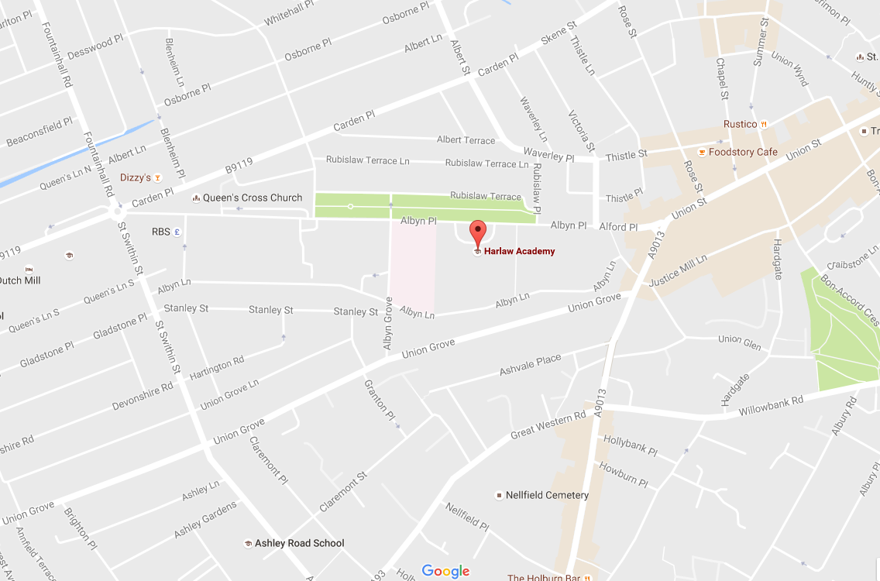

Bus Routes:
- Take any bus to Holburn Junction and walk up to Albyn Place.
- No. 11 and 13 go past the school.

Hazlehead Academy

Address: Groats Road (off Queen’s Road), Aberdeen, AB15 8BE
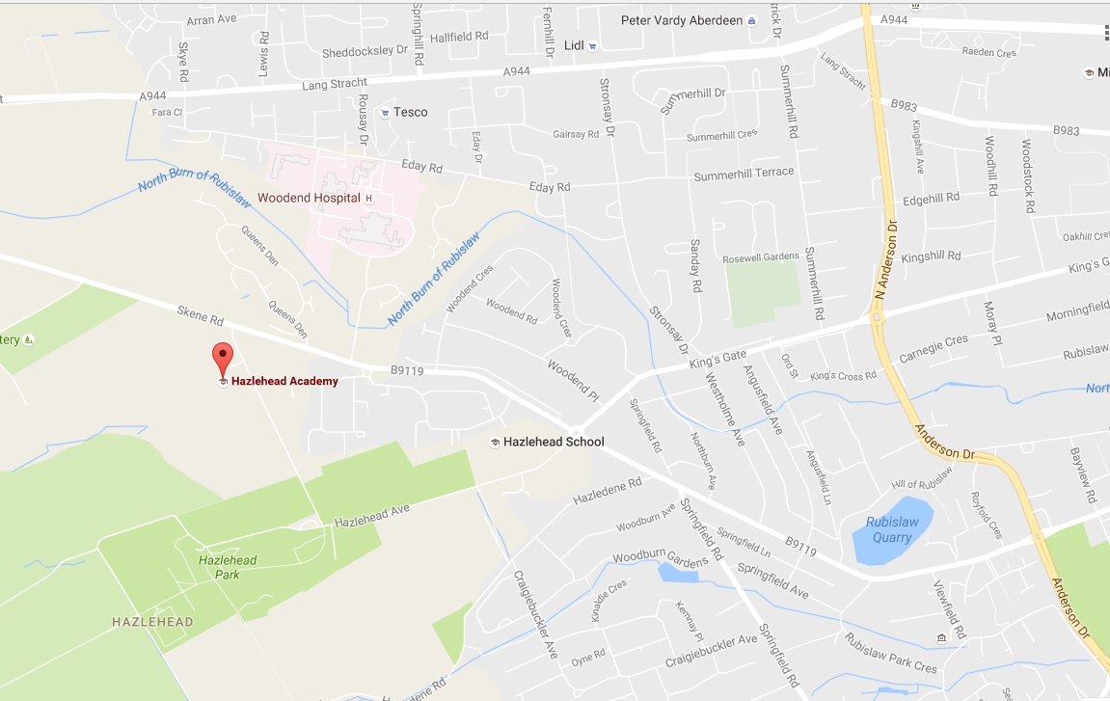

Bus routes:
- No.11 to the terminus opposite Woodend Hospital. Either walk up Queen’s Road a little further, then turn left onto Groats’ Road, or take the short cut over the (public) grassy area. (Which can be soggy!)

St. Machar Academy

Address: St. Machar Drive, Aberdeen, AB24 3YZ
Bus routes:
No. 1 or 2 to King Street – get off near the roundabout at Seaton, then walk up St. Machar Drive
No. 17 or 18 along Great Northern Road, get off at roundabout and walk down to school
No. 20 to Aberdeen University at St. Machar Drive, then walk up to the school.

Citymoves Dance Space

Address: Top floor, Triple Kirks, Schoolhill, Aberdeen, AB10 1FQ

Bus routes:
- Any bus to Union Street, then walk down Belmont Street. Citymoves is on the corner, opposite the Art Gallery. (Above the Triple Kirks bar)

