Your Ref:
Our Ref: GS
Contact: Gael Simpson
Location: Marischal College

Date: 17 December 2020

Dear Parents and Carers

On Friday 18th December at 6pm, Aberdeen City will enter Protection Level 3 until further review the following week.

The guidance for schools, outlines the measures to be considered or actioned within each protection level. Following this guidance and if we remain in Protection Level 3 on our return to school in January, all Staff and Senior Phase pupils will be required to wear a face covering in class, unless exempt.

All other pupils and staff will continue to wear face coverings when moving around communal spaces in schools, unless exempt. Where staff require to have closer contact (within 2m) with children and young people a fluid resistant face mask will be worn.

I would really appreciate if you could help us comply with the national guidance by supporting your child to wear a face covering at the times identified above. If we return to Protection Level 2, there will be no changes to the current arrangements in place to date.

Each school holds a small stock of additional, reusable face coverings for those who are unable to provide these or forget them. Please try to wash these and reuse them to help with management of stock for those in need.

Many thanks for your continued support of schools over this term.

All the very best over the festive period.

Yours sincerely
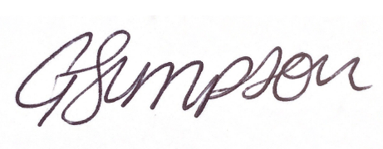

Gael Simpson
Quality Improvement Manager

