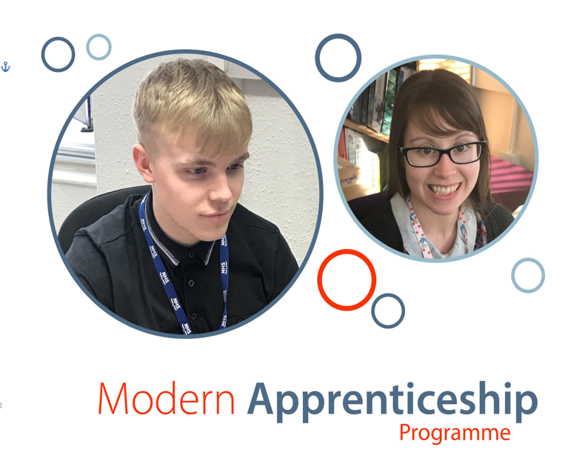

Modern Apprentice

**Business Administration**

It is hoped that the successful candidate will be able to commence employment in July/August 2021 and will be based at Stonehaven Medical Group.

The training programme will be coordinated and assessed by a recognised training provider over the 2 year period. The successful application will be required to complete the Business Administration Qualification (SCQF Level 6) and a work-based evidence portfolio in addition to other personal development activities associated with the post.

Applicants should ensure that their supporting statement within their application is comprehensive and informative.

**Are you enthusiastic and interested in making a contribution to healthcare within Grampian?**

If so, we are currently looking to recruit the following position to work at Stonehaven Medical Group.

* **Modern Apprentice – Business Administration**

Salary : (£13,510 - £15,070)

37 hours per week,

4 days 8:30am – 5pm

1 day 8:30am – 4:30pm

2 year training contract

Applicants must possess the following qualifications at the time of application:

**A minimum of 5 National 5 Grades (or equivalent) at A or B in English & 4 other subjects of your choice.**

**For informal discussions contact:**

**Jackie Paul or Sarah Robertson**

**0345 337 1160**

**Application closing date:**

**Monday 28th June 2021**

**Interview date:**

**Week Commencing 12th July 2021**

In line with Skills Development Scotland **‘Developing the Young Workforce: Scotland’s Youth Employment Strategy’** – these posts are open to 16 – 19 year olds only

