BRIDGE OF DON ACADEMY

How can parents/carers support learning?

Bridge of Don Academy Awards Ceremony
Beach Ballroom
Aberdeen

HOW CAN PARENTS SUPPORT LEARNING?

Ready to Learn

When you send your children to school ready to learn it is one of the most important things you can do, as a parent. Young people learn best when:
They have had enough sleep!

They have a healthy balanced diet!

They have the right equipment for school!

They bring pens, pencils, ruler, rubber planner, bag
They are ready to be their best!

Learning to Learn

Every time you encourage your children not to give up you are doing something very positive to help them learn. The most successful people in life are those who don’t give up even when things are really difficult. This quote from Michael Jordan, the famous American Basketball player, sums this up perfectly.

I've missed more than 9000 shots in my career.
I've lost almost 300 games. 26 times, I've been trusted to take the game’s winning shot and missed.
I've failed over and over and over again in my life.
And that is why I succeed.

Learning New Skills

Skills for Life, Learning and Work

The world of work is changing rapidly and it’s our job to equip children and young people with a set of skills that will help prepare them for any job. Employers value skills like:

Problem Solving

Communication

Aiming High

Resilience

Study Skills

Social Skills

The following speech bubbles contain the views of some of our senior pupils on how school has helped them develop skills and what you as parents can do to support this:

Always encourage your children to talk to everyone in their class – they may end up making new friends. Almost all my close friends now are people I met in S1.
Communication Skills

Try and join extra-curricular activities like Student Council so you can talk about issues that may concern you.

In my experience teachers have always involved pupils in class discussions about topics the have been covering and encourage all students to put forward their ideas.
Throughout the school, communication skills grow with pupils and teachers listening and talking. It might be slow at first but as time goes on it will grow through group work and tasks but also just as part of school.
My communication skills have got better because the teachers make it easy to speak to them and help.
Problem Solving Skills
For example, in Biology, working as part of a group to complete an experiment and work things out. It’s ok if you get things wrong – it’s a good way of learning.

At school there are a lot of challenges from teamwork/leadership activities to balancing your time so that you can get your homework done. These all help to develop skills for after school.

Finding more than one way to do something opens your mind to different possibilities. Parents should allow (encourage) their children to find their own suitable solutions rather than tell them what they would do.
After my parents encouraged me to join Duke of Edinburgh award scheme in S3, I have continued to develop problem solving skills with each level while on expedition.
Ensure the kids know that giving up on something because it’s difficult is as good as not trying at all, and that persevering will improve them in the long run.
Resilience

The ability to bounce back from disappointments and cope with challenges.

This school has taught me that it isn’t possible to be good at everything but you don’t know until you try – so give everything a go!

I really wish my parents had given me advice like this on how to cope with disappointment which makes bouncing back from them a whole lot easier.

Teachers will offer you great support and alternative ways to increase your learning – for example if you fail a test. Parents can support their child by encouraging them to keep going and put the disappointments to the back of their mind.

If you don’t have a rock bottom then there’s nothing to grow from. The successes that come from hard work and in spite of setbacks are the ones they will remember most.

Aiming High
Although your dreams are important, you have to work hard to get to where you want to be and be persistent.

Lionel Messi said “You have to fight to reach you dream. You have to sacrifice and work hard for it.”

Don’t pressure your child to pass encourage them to do THEIR best!

Aiming High and achieving at BODA comes with rewards. Pupils get recognition for their good work and good attitude, for example, merits, Award Ceremony, Drama Night, work showcases.

Always try your best in all your subjects to give yourself options when choosing subjects. The harder you work the easier and more enjoyable the subject will be!

Social Skills
Talk to as many people as you can within the first few days to make new friends. Get to know your classmates early on.

Being part of school show since my first year at Bridge of Don has really helped to build up my confidence and, even if you don’t want to leave school and do theatre, it’s a great way to meet people. .

Expand their social network. Get them doing things out of their comfort zone early on.

Don’t push them to make friends. They will make them in their own time – took me three years before I found my friendship group.

Don’t be afraid to ask any member of staff or any senior (people wearing a red tie) if you have a question or are lost. We are here to help you.

We are encouraged to do a lot of group work which improves both our social skills and our communication skills with other people. .

Study Skills

The most important thing about study skills is good habits. From S1 we encourage young people to get into a good routine. By reminding them to check their planner each evening to see what homework they have coming up, you are helping them to prepare for the week ahead and not just for the next day. Supporting your child to pack their school bag the night before and to take their school bag every day with the basics of a pencil, pen, ruler and rubber – and of course their planner – will encourage good organisational skills as well. Lockers are available in school for the storage of books and equipment so they do not have to carry a heavy bag about all day.

When you encourage them to ask for help if they need it from teachers you are encouraging their independence but also their perseverance and resilience, but please do not hesitate to contact the Head of House or Year Head in school if you have concerns about your child’s progress.
Everyone is different so the children need to find what’s best for them as soon as possible, for example, mind maps, post-it notes, rewriting class notes audio notes etc.

Dedicate a couple of hours a week to studying and consolidating things you have learned in class. There are resources online to help you keep up with the work and teachers are always willing to help you if you ever find yourself struggling.

Trying different methods like flashcards and using different colours for notes helps. Revising with siblings or parents can be good as you know you’re getting it done.

Homework and Home Learning

In some ways the word ‘homework’ is very old-fashioned, as if there are only two places where children can learn – if it's not school, then it must be home. The curriculum is everything learners do – school work, homework, sporting activities, artistic pursuits, participation in clubs and organisations as well as family activities like walking, swimming and visits.

However way we describe it, teachers, pupils and parents agree that homework, or work done outside school, is useful for many reasons.

- It builds on understanding of skills and content begun in school
- It allows young people to spend as long as they wish on a piece of work
- It helps parents understand more about what their own children are learning in school
- It helps to develops good study habits
- It fosters independence and self-discipline – especially when young people spend an extended length of time on an activity
- It builds confidence
- It allows young people to demonstrate responsibility
- It broadens horizons
- It provides challenge(s) to stretch young people
- It’s fun and interesting to visit new places or take part in new activities

The web address below contains further advice for parents on supporting learning outside school.

http://www.parenting.co.uk/education/homework-tips.cfm
Parents - talk to your kids! Encourage a reluctant child to do homework – try setting a time limit and offering a reward. It’s all about getting into good habits early! Prepare your child for disappointment and hard work!

It important to recognise that homework can be a real source of stress for some students – even if it seems simple. Just letting us know that we are supported is often then best help you can give.

Don’t leave it to the last night before the due date. You will fail unless you are some kind of genius!
Encourage them to do homework as soon as they get it. Procrastinating will only get worse through the years if your child does not establish a good work ethic.
Remind them if they work hard now. It will be worth it in the future when they manage to get their dream job!
Parents should definitely be supportive and encouraging of homework and take the time to sit down and help them if they are reluctant. Try to ensure that it does get done and if it’s not then try to be patient and ask why, then help with whatever it is they need.

Try and help your child if they still do not understand you can always tell them to ask their teachers to help explain the question or task.

Study Space

One of the best things parents and carers can do to help is to give encouragement. However, young people do benefit from having a small space to study with an area they can work on with a good light. If they can have access to the internet that will also be beneficial but all advice is that this should be in a public area of the home rather than their bedroom. If they are aware that you are around they are less likely to be drawn into behaviour that is risky or dangerous. The following website gives useful advice to parents and carers about how to keep their children safe on line. https://www.thinkuknow.co.uk/parents/

There are also videos about other internet safety matters. This one by the BBC is very good.
http://www.bbc.co.uk/webwise/0/21259413

Internet safety is also covered in ICT lessons in S1.

Google Apps for Education

Aberdeen City Council has provided all pupils with a ‘Google Apps For Education’ account. This is a Google account which can be used by pupils to access Google tools and software, including Gmail, Google Drive, Docs, Sheets, and Classroom. It is an educational account only and will have no link to any personal Google accounts the pupils may have and as such it is subject to the usual monitoring that any Educational Account would face.

Bridge of Don Academy’s teachers and pupils are now making use of Google Classroom as a way of setting and submitting homework, providing resources and information related to courses including lesson plans and objectives and communication with pupils in class. Pupils can use the message service to ask for help. Pupils are also being encouraged to save their work to their Google Drive in order to have access to it from home. Pupils are asked to download the Google Classroom App for free onto their smartphones and tablets (Apple and Android) at home, and to add the Classroom App to Chrome on their PC/laptop. If you would like more information please contact the school. Young people who have no internet access at home are welcome to use facilities in school at lunch time – in the library or study clubs. The school library is also open after school.

Library

The school library support our literacy programmes in a variety of ways and work closely with teachers in the English and literacy faculty to do so. The library is open before and after school and every lunchtime. The popular library club provides time and space for young people to access computers for their school work, board games for socialising and peer support from senior pupils – The Buddies. However the librarians are also there to encourage reading.

There is strong evidence (http://www.oecd.org/pisa/pisaproducts/48852630.pdf) linking reading for pleasure and educational attainment. It is one of the best ways for a child to improve his/her performance at school. We also know that reading can contribute to mental wellbeing.

What parents can do to encourage reading

- Encourage your child to set aside some regular time for reading, perhaps at bedtime.
- Display books somewhere in your home to let children know that books are important and don't limit the books to a few essentials... have a generous selection of a wide variety of books.
- Research shows that children that are surrounded by readers – be that parents, siblings, friends, or teachers are more likely to become readers themselves. So let them see you reading, talk about it and share your views about books you have enjoyed. This sends a message that reading is a worthwhile activity.
- Don’t pressurise your children into reading what you think they should read. Reading is highly individual and criticism can be counterproductive. As well as books, you could suggest reading in different formats such as magazines, newspapers, graphic novels and manga.

Not sure what books your child might enjoy? Reading suggestions can be found on the Library pages of the school website. (www.bridgeofdon.aberdeen.sch.uk)

Also have a look at the following sites:

http://www.scottishbooktrust.com/reading/book-lists/themes/8-11
http://www.scottishbooktrust.com/reading/book-lists/teens
https://gcbookaward.wixsite.com/gcba
https://www.worldbookday.com/reading-ideas-youll-love/
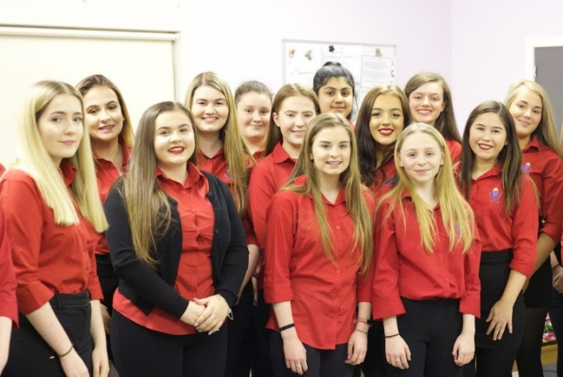
Extra-Curricular Activities

When you encourage your child to get involved in activities beyond the classroom you are supporting their development of many skills. They will learn lots by being part of groups and organisations that encourage them to push themselves, to be resilient and to learn new skills. Young people benefit from the social aspects of such groups too – they learn how to get on with people they don’t know well, how to work with adults in authority and when they achieve success it boosts their confidence. If young people participate in an activity over a long period of time it demonstrates perseverance and an ability to apply yourself to something that takes effort. These are qualities and skills valued in the workplace. The important thing is to get involved and to have activities for the evenings and weekends that get them out and about and making new friends to broaden their horizons. This will support their mental health as well as their physical health.
We offer a number of extra-curricular activities in school – at lunch times and after school. Ranging from football, chess, cosplay, choir, to Maths and Science clubs and the library’s Book Club. See the link below to access the full timetable https://bridgeofdon.aberdeen.sch.uk/wp/?page_id=6108 or visit ‘Extra Curricular’ under the Wider Achievement section of the school website.

Please don’t let finance be a barrier to participation. Our school fund and pupil equity fund are there to support young people who have to travel to events, need help with fees or who just need a little bit more support. Please contact your child’s Guidance Teacher to find out more.

What’s going on in school?

The school website is a great source of information. We often use GroupCall to alert you to useful information or letters that have been issued so that you do not just have to rely on bag mail. Please download the GroupCall app to help us keep text and postage costs down.

Attendance

Young people who attend school regularly will achieve more than those who do not. We aim for 100% attendance for all our young people but of course they do get ill. The procedure for reporting this is detailed in the School Prospectus. We don’t want you to send your child to school if they are too ill to learn but a cold or a general feeling of being unwell can often be worked through. Eating well, getting enough sleep and drinking plenty water can make a huge difference to how we all feel. Persevering when you don’t feel your best is important, especially as we prepare our young people for the world of work.

Please don’t be alarmed if your child is reported as absent and you have sent them to school that morning. We try hard to make sure absence information as accurate as possible but sometimes mistakes are made. If you get an alert please phone the school and we will double check. It can be a bit worrying but we would rather report a child as absent to a parent and find it is a mistake than the other way around.
What Are We Trying To Achieve?

Our school aims and values really sum up what we are trying to do with and for the young people of Bridge of Don Academy. We want all young people to become:

- Successful Learners
- Confident Individuals
- Responsible Citizens
- Effective contributors

We believe that they will achieve these aims if, with your support, they try really hard to:

- Be Honest
- Be Caring
- Be Respectful
- Be Their Best

The following are useful sources of information:

School Website – www.bridgeofdon.aberdeen.sch.uk

Facebook – Bridge of Don Academy Official – this is linked to our school website.

Scottish Qualifications Authority – information about SQA exams - www.sqa.org.uk

NPFS - National Parent Forum of Scotland has produced Revision in a Nutshell guides for the new Highers (20 subjects) and updated Revision guides for National 5s (20 subjects). These revision guides contain direct links to SQA specimen question papers, exemplar question papers plus past question papers, where appropriate. The guides advise learners to check with their teachers to make sure that material is relevant. The guides are primarily intended to provide the SQA direct links by subject in one place, and to give some additional revision opportunities.

http://www.npfs.org.uk/new-higher-revision-guides/
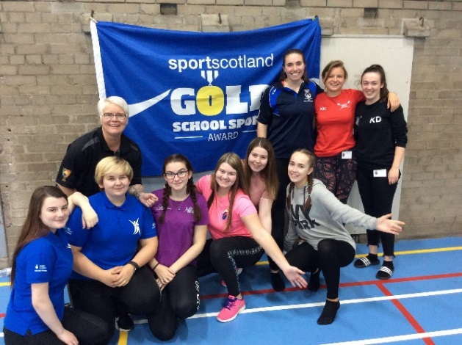
http://www.npfs.org.uk/national-5-revision-in-a-nutshell/

