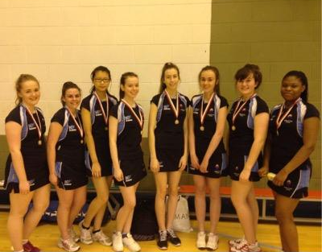
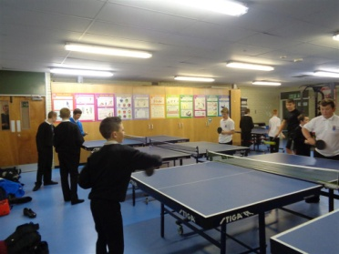

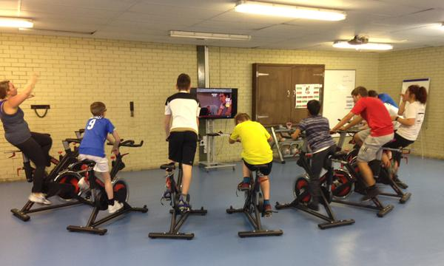
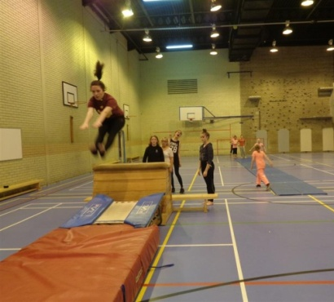
BRIDGE OF DON ACADEMY
Extra-curricular Sports 2015-2016
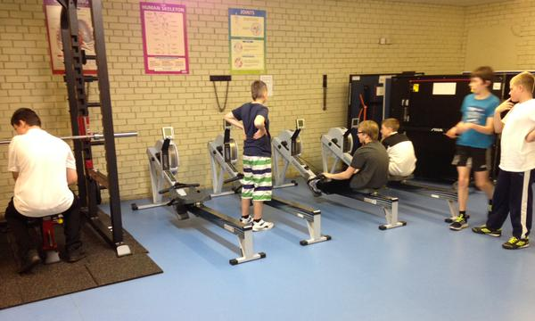

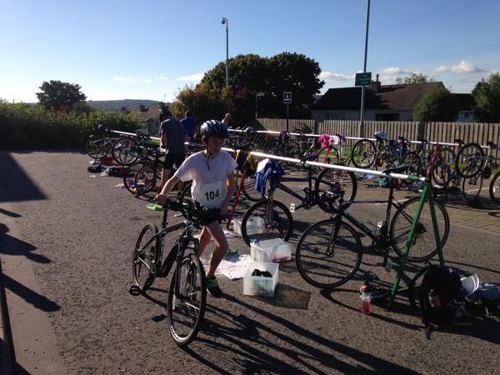

ACTIVITY VENUE TIME PEOPLE RESPONSIBLE
MONDAY
Lunch Time Activities
S1/2 Netball Games Hall 1.20 – 1.50 Allana R. and Miss Barr
Volleyball Games Hall 1.20 – 1.50 Mr Jappy
Triathlon Activities Room 1.20 – 1.50 Arianna S. and Mr Wallace

After School Activities
Staff Fitness Games Hall 4.15 – 5.00 Miss Barr

TUESDAY
Morning
Gymnastics Games Hall 8.05 - 8.35 Jay M. and Miss Barr

Lunch Time Activities
Girls Football Outside 1.20 – 1.50 Bradley P. and Miss Barr
Badminton Games Hall 1.20 – 1.50 Callum B. and Mr Wallace

After School Activities
Basketball (S1-6) Games Hall 4.00 – 5.00 Shannon M. and Miss Guthrie

WEDNESDAY
Lunch Time Activities
Table Tennis Activities Room 1.20 – 1.50 Lewis B. and Mr Jappy
Gymnastics Games Hall 1.20 – 1.50 Jay M. and Miss Barr

After School Activities
Dance Activities Room 3.00 – 4.00 Allana R. and Miss Davidson
Senior Netball Games Hall 3.00 – 4.00 Miss Barr
S1/2 Football Outside 3.00 – 4.00 Mr Donald

THURSDAY
Lunch Time Activities
Futsal Games Hall 1.20 – 1.50 Bradley P. and Mr Donald
Indoor Rowing Activities Room 1.20 – 1.50 Mr Wallace

After School Activities
P1-7 Basketball Games Hall 3.45 – 5.00 Miss Guthrie

FRIDAY
Morning
Badminton Games Hall 8.05 - 8.35 Mr Donald

Lunch Time Activities
Dodgeball Games Hall 1.20 – 1.50 Scott K. and Mr Donald
Girls Only Session Activities Room 1.20 – 1.50 Shannon M. and Miss Barr

After School Activities
Staff Football Games Hall 3.15 – 4.15 Mr Haggerty

