Partners Digital Pack
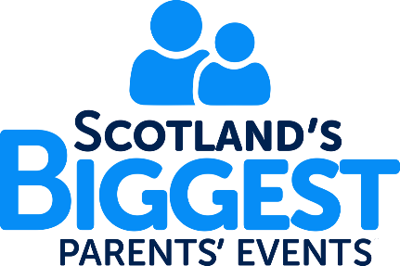
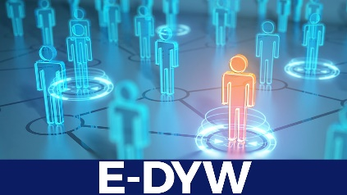
Contents page

Page 1 – About DYW Summer Leavers’ Programme 2020
Page 2 – 4 - Scotland’s Biggest Parents’ Event (SBPE)
Page 5 – 10 - DYW Skills Academy: Get Industry Ready
Page 11 – 12 - Promotion

About DYW Summer Leavers’ Programme 2020

Developing the Young Workforce has created a jam packed programme of content aimed at supporting young people leaving school this summer to take their next steps in life. An online portal E-DYW has been created, it is a One-Stop-Shop for young people, educators, employers, parents/carers that can be accessed at https://www.dyw.scot/. It will include multiple resources from private & public sector bodies to provide support to young people leaving school this year.

A series of sessions have also been created to support both young people, parents and carers delivered through our Scotland’s Biggest Parents’ Events and DYW Skills Academy.

Scotland’s Biggest Parents’ Event (SBPE) series is aimed at providing information and relevant updates on topics that are of interest to support young people with the transition from school. The first event will take place on Tuesday 7th July 2020.

The DYW Skills Academy: Get Industry Ready delivered over July and August is a series of activities and virtual experiences with industry to support young people to build capacity to enter the labour market.

As a DYW Partner we would value your support to raise awareness of DYW Summer Leavers’ Programme 2020. This digital pack can be used across your marketing and communications channels to help promote the programme, and your involvement within it.

Page 1
Scotland’s Biggest Parents’ Event (SBPE)
Developing the Young Workforce are excited to launch our first virtual Scotland’s Biggest Parents' Event Series!
Our Scotland’s Biggest Parents’ Events are a series of four broadcasts running throughout the summer, which will allow parents, carers and guardians to hear about the things that matter to them right now.
The events will provide parents and carers with information about options and next steps for young people, including where they can go to make informed judgements to support their young person's next steps.
With input from a range of experts covering topics such as exams, mental health, apprenticeships, skills development and pathways into industry, the events aim to provide a message of reassurance and optimism to parents and carers at this challenging time.

Page 2
Below is a road map of what the four SBPE broadcasts will look like and what each one will cover:

Page 3

The first event will be particularly beneficial to young people who have just left, or are about to leave, school.
The event will take place on Tuesday 7th July, 7:00pm – 7:30pm and provides an opportunity to hear from a range of experts from organisations such as Young Scot, the Scottish Qualifications Authority as well as directly from employers.
The event will be premiering on Young Scot’s YouTube and Facebook Channels. All events will be pre-recorded (no live element) and snippets edited together by a professional media company. Young Scot will moderate comments and collate relevant questions and insights on DYW’s behalf.
Registration for the event will be via Eventbrite and will open week commencing Monday 22nd June and close on Tuesday 7th July. An overview of SBPE including the Eventbrite link – can be found at www.dyw.scot/sbpe.
Further information on content and how to register for forthcoming SBP events, due to take place on the following dates will be issued in due course.
SPBE Event 2 – Vocational Pathways (21st July)
SPBE Event 3 - #NoWrongPath to Industry (4th August)
SPBE Event 4 – Pathways to Priority Industries (15th September)

Page 4
DYW Skills Academy: Get Industry Ready
DYW have made a commitment to deliver a DYW Skills Academy: Get Industry Ready experiences over the month of July and August which includes delivering a series of virtual activities and employability experiences for young people leaving school summer 2020. Alongside this there will be wider access to virtual experiences through E-DYW.

Who is the DYW Skills Academy for?
Certain elements are open to all young people, others are more targeted to young people looking to progress into employment/social mobility and those applying for jobs and apprenticeships. The e-learning and mock interviews/CV checks are only for those progressing into employment from school as a priority.

Young people will have from the 23rd June – 12th July to register for the DYW Skills Academy and register via www.dyw.scot/skills-academy

Page 5
Below is a road map of the DYW Skills Academy series of virtual activities and employability experiences:
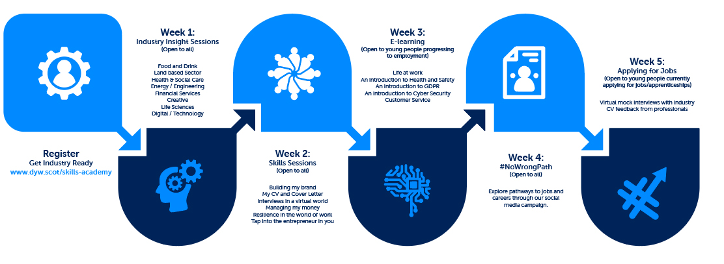

Page 6
Below you will see an overview of the DYW Skills Academy sessions:

Week 1 – 13th July - Industry Insight Sessions (Open to all young people)
The Industry Insight sessions will offer an opportunity to find out about the key demand sectors emerging from Covid-19. There will be an opportunity to find out about the career opportunities available within each and find out what is expected in the workplace including, key skills, qualifications and experiences.

Please see below the following employers who will deliver these sessions:
- Food and Drink – Dawnfresh
- Land based sector – Lantra
- Health – NHS
- Social Care - SSSC
- Energy – Energy Skills Partnership
- Financial Services – Scottish Financial Enterprise and HSBC
- Creative – 4J Studios
- Life Sciences - Antibody Analytics
- Digital/Technology – Servelec

Page 7

Week 2 – 20th July - Skills Sessions (Open to all young people)
The Skills Sessions will offer the opportunity to build on key skills that will support young people to get the insight they need to find their pathway to industry. They will learn how to build their online brand, the do’s and don’ts when writing CVs and Cover Letters, how to perform in a virtual interview, how to manage their money, what resilience looks like in the world of work and also the opportunity to develop their entrepreneurial skills.

Week 3 – 27th July - E-Learning (Open to young people progressing to employment after school)
There are a select few online short courses to be completed as part of the programme. The following will be work through each of the following topics: Cyber Security; Customer Service, GDPR, Health and Safety and Life at work. Each of the courses will provide a good foundation of knowledge to support strengthening a young person’s CV and applications for employment.

Week 4 – 4th August - #NoWrongPath (Open to all young people)
It is exam results week, we plan take the pressure off this week to ensure young people have time to anticipate and digest their results. We will signpost to the wider #NoWrongPath and wider support on offer.

Week 5 – 10th August - CV feedback from professionals (Open to young people actively applying for jobs and apprenticeships)
Young people intending to go straight into employment after school will get the opportunity to have their CV checked by a professional. They will receive constructive feedback on how they can improve their CV to make any necessary changes, making sure their CV stands out from the crowd.
Page 8
Week 5 – 10th August - Virtual Mock Interviews (Open to young people actively applying for jobs and apprenticeships)
Virtual mock interviews are taking prominence right now, if a young person is intending to go straight into employment after school, they will get the opportunity to have a virtual mock interview with a professional. It will boost their confidence through practice and provide them with first-hand experience on how a real-life virtual job interview will feel.

DYW Skills Academy Registration Process
All young people will sign up via Mailchimp link via the DYW Scot DYW Skills Academy Landing Page. Thereafter they will receive automatic updates every Monday on what activity they will be doing that week and how they can access it. This will be done centrally and come from a national message.

Page 9
Partners should use the below image when promoting out the DYW Skills Academy on social media or direct to young people to encourage them to sign up.

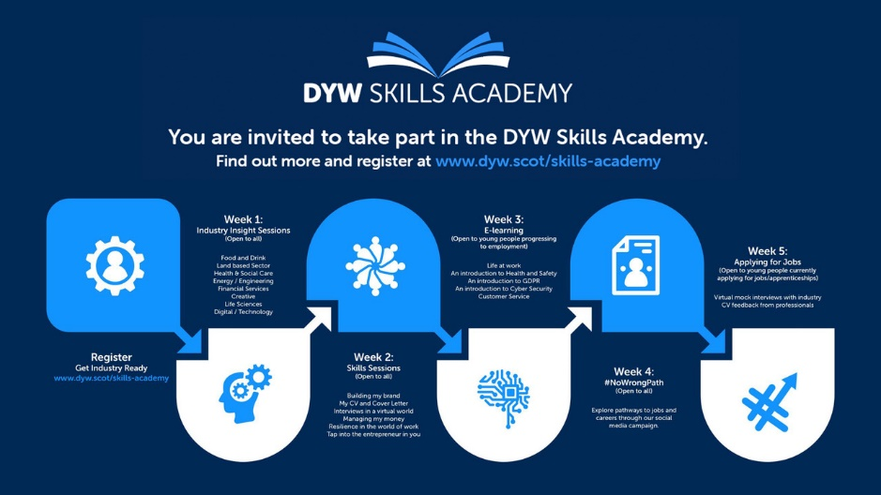

DYW Skills Academy booking link - www.dyw.scot/skills-academy Page 10
Promotion
As a partner of DYW we would encourage you to spread the word about DYW Summer Leavers Programme by:
- Sharing Information about Scotland’s Biggest Parents Events (SBPE) and the DYW Skills Academy activities on your website encouraging parents and school leavers to sign up
- Promoting out Scotland’s Biggest Parents Events (SBPE) and the DYW Skills Academy activities on your social media channels encouraging parents and school leavers to sign up
- Connecting with other DYW partner organisations across all channels and share their messages
- Connecting with other DYW groups and share their messages across your social media platforms on

Social Media
In the run up to each of the Scotland’s Biggest Parents Events (SBPE) and the DYW Skills Academy activities partners should create posts promoting the events and encouraging parents and school leavers to sign up. If partners are in the position we would suggest boosting the posts for both of these events for further reach.

Page 11
Partners should be using the hashtags #DYW20SkillsAcad and #DYW20SBPE when promoting out posts across their digital channels.

Promotion Timeline for SBPE and DYW Skills Academy: Get Industry Ready

Please find below a promotion timeline for Scotland’s Biggest Parents Events (SBPE) and the DYW Skills Academy activities. All partners are encouraged to follow the timeline using the suggested social media posts provided to promote SBPE events and the DYW Skills Academy in the run up to the events.

Graphics and Logos
You will find below in the attachment all social media graphics and resources needed for the DYW Summer Leavers Programme 2020.

If you need any graphics in an alternative format or size, or need further assistance then please contact danielle@dywayrshire.com
Page 12

