Your Ref:
Our Ref: ES/SP
Contact: Eleanor Sheppard
Location: Marischal College

Date: 30 September 2020
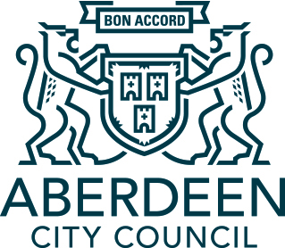

Dear Parent/Carer

SQA Exam diet

On 16 September, John Swinney, the Deputy First Minister, in his opening statement to the Education and Skills Committee, advised that the SQA pause publication of the outcomes of their consultation on modifications to National 5, Higher and Advanced Higher courses for the 2020-21 session and the 2021 exam timetable. Mr Swinney has asked that the SQA delay until publication of the Priestly Review.

We anticipate an announcement from SQA on Tuesday 6 October regarding any modifications to the national qualifications and the 2021 exam timetable. I hope to write to you again on Wednesday 7 October with more information on what this will mean for our young people in S4, S5 and S6.

In the meantime, please be assured that our schools have rigorous assessment procedures in place and will implement any actions required when we are in receipt of information from the SQA regarding the approach to assessment and certification for the 2021 cohort.

On speaking with Headteacher colleagues, they have shared how much they appreciate the support received from parents in their own school communities. I thank you for this and your ongoing support.

Yours sincerely

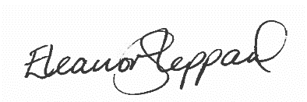

Eleanor Sheppard
Chief Education Officer

