BRIDGE of DON ACADEMY
PHYSICAL EDUCATION DEPARTMENT

BASKETBALL
STRUCTURES AND STRATEGIES
STUDENT BOOKLET

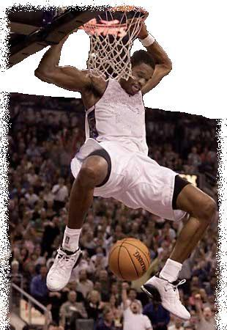

Use the information contained in this booklet together with the data you gather throughout the course to complete the full Cycle of Analysis at least once.

Name: ____________________________ Teacher: _________________________
Structures and Strategies: Basketball
Unit Overview

3 Man Fast Break
Why the fast break?
What are its strengths and weaknesses?

Observation Schedules (Video)
Initial Data Why is it important to gather information?
Knowledge of Results Why do we use these methods of data collection?
Focused Data (Attacking Phase)
*******************************************************************************************************************************************

Analysing your role in the strategy
Compare to Model Performer Strengths and weaknesses of your performance.
(Criteria and Video) Strengths and weaknesses of team performance.

*******************************************************************************************************************************************

Programme of work to improve strategy When and why to refine/adapt strategy.
(Repetition drills & game – like practices) Consider demands placed on you by opposition.
Adapting strategy (Pass to Left/ 1-2 with Forward) Making effective decisions under pressure.

*******************************************************************************************************************************************

Observation Schedules (Video) Why is it important to monitor/evaluate the
Knowledge of Results strategy after development/ adaptation?

********************************************************************************************************************************************************
STRUCTURES AND STRATEGIES

CONTENTS

Key Concepts and Key Features
An Introduction to Basketball - Structures and Strategies

3 Man Fast Break
1 Investigate
1.1 Description of the 3 man fast break
1.2 Methods of Analysis

2 Analyse
2.1 Roles and Relationships
2.2 Technical, Personal, and Physical qualities
2.3 Group and Team principles
2.4 Tactical and Design Elements
2.5 Strengths and weaknesses of team performance

3 Develop (Course of Action)
3.1 Developing Performance
3.2 Our Weakness
3.3 Programme of work to develop and improve performance
3.4 Adaptations based on demands placed on you by opponents
3.5 Alternative Strategy – 1 Man Fast Break

4 Review
4.1 Monitoring and Evaluating

Zone Defence
Basic principles
Strengths and weaknesses
2-1-2 Zone Defence (Team Principles)
Principles used against a Zone defence/Adapting strategies
Man to Man (Team Principles)

Rules
Glossary of terms
Performance Marking Guidelines

KEY CONCEPTS AND KEY FEATURES

Key Concept 1
The structures, strategies and/or compositional elements that are fundamental to activities:

Key Feature 1
- Using space in attacking and defensive situations
Creating space in attack (Filling the lanes)
Manoeuvring in and out – manoeuvring opponents
Passing or running into space created

- Pressurising opponents in attacking and defensive situations
Overloading a defence when in attack (Fast Break)
High tempo of the fast break causes confusion and errors in defence

- Principles of individual and team play
Width in attack (Filling the lanes)
Depth in attack (Positioning of the guard in the final phase)
Mobility in attack (Adapting the strategy to meet performance demands)
Communication in each for co-operation and support

Key Concept 2
Identification of strengths and weaknesses in performance in terms of: roles and relationships; formations; tactical and design elements; choreography and composition.

Key Feature 1
In terms of Roles and Relationships:

- Recognising individual strengths and weaknesses in a structure/ strategy/ composition
Analyse your role within chosen structure/ strategy.

- Recognising the demands of individual roles during performance
Physical, personal and technical qualities needed for successful individual performance (Guard, Centre and Forward)
Performing under active pressure

Key Feature 2
In terms of Formations:

- The benefits and limitations of various systems of play
Why run the fast break?
Strengths and weaknesses of chosen structures/ strategies

- The need to cooperate and support others in team or group situations
Processing information and making decisions on when to apply and when to adapt various systems, as a team, in a game situation
Support play in the fast break (Filling the lanes)

Key Feature 3
In terms of Tactical & Design Elements:

- Identifying and exploiting opponents’ weaknesses
Recognising opponents individual and team weaknesses and knowing how best to apply a structure/ strategy which can take advantage of highlighted weaknesses

- Recognising the need to maximise strengths within chosen structure/ strategy
Using individual and team strengths to select, apply and adapt a structure/strategy

Key Concept 3
Information processing, problem solving and decision making when working to develop and improve performance

Key Feature 1
- The importance of evaluating the effectiveness of current structures/ strategies in individual and team situations during performance
Using data collection through Observation Schedules (in conjunction with video analysis) and Knowledge of Results to evaluate the effectiveness of chosen structure/ strategy.
Why it is important to gather information on the current structure/ strategy
Why it is important to evaluate the structure/ strategy after development
Why are the methods used appropriate?

Key Feature 2
- How to adapt and refine structures/ strategies in response to performance demands
Experiencing drills and game – like practices to improve a chosen structure/ strategy and prepare adaptations based on the response of the opposition.
(Fast break options – creativity and improvisation)

Key Feature 3
- The importance during performance of continually being creative, making good decisions under pressure and exercising effective solutions
Showing awareness and understanding of when to adapt structure/ strategy in a demanding environment to ensure performance remains effective.

AN INTRODUCTION TO BASKETBALL - STRUCTURES AND STRATEGIES

Basketball is a fast moving dynamic game, which constantly, presents varied problems and challenges for players. During training sessions players should practise set moves, in order to meet a variety of game demands. The ability of players to participate or execute a strategy or tactic is vital for winning the game.

Structures
These are designs or formations that groups of players would agree to collectively deploy during the course of their play in an attack or defence in basketball. Depicting a structure might denote individual positions or places for individual players in a way that would enable their attributes and particular skills to be acted out in a meaningful and productive way.

Strategies
This is the management of the tactics and skills of the game. These are the details of playing and performing which specify more precisely what the players might hope to achieve during the course of the game. This can be an immediate next stage (setting up the fast break in a game), or longer term planning, such as preparing for a league championship final.

Tactics
These are about decision making and problem solving. It is a shorter term deployment of players with a specific short term goal. Tactics are often decided in a ‘timeout’ especially if you need something special in the last few moments of the game. They make good use of individual skills and involve more than one player.

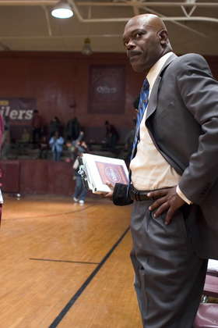

NORTHFIELD ACADEMY
PHYSICAL EDUCATION DEPARTMENT

BASKETBALL
STRUCTURES AND STRATEGIES
HIGHER

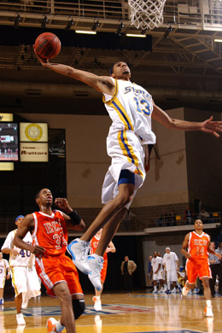

3 Man Fast Break

1.1 DESCRIPTION OF THE 3 MAN FAST BREAK

The 3 man fast break should be the first option of any offence. It is played at speed as soon as the rebound is collected. The fast break should be used under the following situations;

- After a rebound
- After a steal
- After a blocked shot
- After a successful shot

The fast break is the ultimate offensive weapon. It allows the ball to be advanced up the court quickly for a high percentage shot, either by outnumbering the defence or by not allowing the defence to set up in time. It provides good width, depth and mobility in attack.

There are three main phases of a fast break;
Defensive Phase - Starting the break (rebound)
Transition Phase - Getting into position and driving the ball up the court (filling the lanes)
Attacking Phase - Finishing with the correct scoring option (Lay-up shot)

- Strategy starts at high speed after winning a defensive rebound or an interception has been made. Centre usually makes the rebound and calls ‘rebound’ to initiate attack.
- The outlet pass is made quickly to the open side (the side the rebound is caught on) to the point guard.
- Guard calls ‘ball’ and receives the pass in the outside lane (after moving from the key where he was actively defending). This is to help the centre; good communication lets them know what is happening.
- Guard ‘dribbles the middle’ with control and keeps the fast speed of attack by reading the game and making quick decisions.
- Guard should drive hard towards the defence making them commit and causing the defence to loose shape.
- Driving down the middle gives the guard an option of passing to both sides (depending on which player can receive the pass in good space) therefore increases the attacking options.
- While the guard dribbles down the middle, the forward and centre should fill the outside lanes ahead of the guard to provide him with more options.
- Guard passes wide to the attacking forward, approximately half way down the court, or when the defender has been drawn out of position. Forward signals with hand to show when and where he wants the ball.
- Forward takes the opportunity to lay-up the shot as soon as the pass has been collected; the centre supports play and challenges rebound.
- A lay-up shot is the 1st option because it has a higher percentage chance of being scored. This is because the distance between the where the shot is taken and the basket is at its smallest.
- If the lay-up is unavailable because of good defending, an outlet pass should be made to the point guard at the top of the key for him to make the decision of shooting from which centre will rebound, or passing to the centre on the other side for a lay-up

1.2 METHODS OF ANALYSIS

In order to ensure our performance was being performed at its best we used 3 different methods to collect information about our performance, this gave us an indication of our success rate and what needs improvement.

Video Analysis
- Allows the player to concentrate on the task without the ‘feeling’ of pressure from observers.
- It is a reliable form of external feedback as once the data is recorded it can be viewed over and over again, allowing the player to focus on different points each time.
- As the fast break is carried out at a fast tempo, it may be difficult to analyse specific phases of the strategy, slow motion allows individual players and phases to be observed easily.
- The video also allows us to view the strategy from a raised platform. This makes it easier to analyse the principles of width and depth.

Data Collection sheets
- Used in conjunction with video.
- Allows a comparison against a breakdown of the strategy taken from model performance.
- There are two main types of data collection used; initial and focussed data sheets.
- Initial data collection allowed us to focus on the three main stages of the fast break by identifying if they were successful or unsuccessful.
From the information we were able to identify that stages 1 and 2 were done well but stage 3 was where the problems occurred, this is when the forward collects the bounce pass from the guard and makes an attempt at the basket with a lay-up shot.
- With this information we then used a focused data sheet to collect further information about our specific weakness.
- The focused data collection sheet broke down all the actions inside the third stage allowing us to pin point exactly where and why our strategy was failing.
- Information collected can be used a base point for planning a course of action and monitoring its success.
From this information we were able to identify that our specific weakness was in the final part of the third phase as the timing of the forwards run meant he/she was unable to drive to the basket unopposed and score with a lay-up shot.

Knowledge of Results
- By counting the number of successful baskets we could quickly and easily measure our success rate as a percentage of overall shots taken.
- This information is useful when comparing our performance of before and after adaptations are made and programme of work is carried out to develop performance.

INITIAL DATA COLLECTION

Analyse how effective your team is at executing the fast break strategy in a 3v3 game of basketball against a similar standard of opposition.

Name: ______________________________________

3 Man Fast Break | Defensive Phase | Transition Phase | Attacking Phase | Comments
1

2

3
4
5
6
7
8
9
10

Key: P = Done well X = Needs improvement

Criteria

Defensive Phase - Rebound
- Fast, accurate outlet pass played to the Gaurd

Transition Phase - Dribble the middle
- Accurate bounce pass played to the Forward

Attacking Phase - Pass collected, Forward just in front of Guard
- Lay up shot

FOCUSED DATA COLLECTION

Structures and Strategies
3 Man Fast Break

Third Phase of Attack | Unsuccessful – incorrect decisions and actions made | Needs Improvement – mostly correct decisions and actions | Successful – correct decisions and actions
Point Guard:
Stops in opponents half, just over half way line.
Ready to play pass

Centre and Forward:
Are in front of point guard
Are in wide positions

Signal for pass

Point Guard:
Selects correct pass

Passes to a player who is signalling for pass

Centre or Forward:
Receives pass

Drive towards basket

Performs lay-up shot

2.1 ROLES AND RELATIONSHIPS

An attractive feature of basketball is that there are no positional restrictions, each player can move anywhere and do everything. However there are three distinct roles that can be identified; the centre, guards and forwards. Centres are often known as ‘post’ players as they operate close to the basket. Guards are sometimes referred to as ‘playmakers’ as they often initiate the attack. Forwards are highly mobile players who operate mainly in the outside lanes of the court.


In every group or team it is essential to understand what your individual responsibilities are and how your role relates to your team-mates. Refer to the following information when analysing your role within the fast break.

Responsibilities - Centre
- Collect the rebound from under the basket
- Make a quick outlet pass to the point guard in the outside lane
- The pass should always be made on the same side as the rebound
- The centre should then fill the lane the guard has left empty
- Move quickly up the court slightly in front of the guard as they are the second option of attack
- Read the game and watch for the pass to be made to the forward
- Once pass is made, cut into the basket ready to receive the rebound if lay-up is unsuccessful
- If centre receives the pass, move into the key and finish with a lay-up

Responsibilities - Guard
- At the start of the strategy the point guard should be positioned at the elbow, this is because up to this point he has been actively defending
- Read the situation as the ‘playmaker’ and receive a quick outlet pass from the centre in the outside lane
- Correct decision is important as of when to play pass out to forward
- Should stop after he dribbles the middle and pass early to the forward (or centre if forward is being closely marked). He only penetrates to the basket if the defence sags (drops back).
- After the pass the point guard should remain at the top of the key, because in this position further offensive options can be set up if the opponents defence is already set up. In addition if the forward and centre cannot drive to the basket for the lay-up the point guard should be ready to shoot from outside the key

Responsibilities - Forward
- Should be out in the outside lane in front of the point guard. Hand out signalling for the pass to be made
- Once forward is inline with the foul line (extended) they should cut in towards basket at a 45 degree angle
- Pass should be received in a shooting position ready to drive towards the basket with a lay-up shot

2.2 TECHNICAL, PERSONAL AND PHYSICAL QUALITIES

Players assigned to each of the roles within the fast break must have certain technical, physical and personal qualities in order for them to carry out their role effectively.

 | Technical Qualities | Physical Qualities | Personal Qualities
Centre | - Rebounding  - Passing | - Height  - Strength | - Confidence  - Determination  - Decision Making
Guard | - Dribbling  - Passing | - Speed  - Agility | - Leadership  - Court Awareness  - Decision Making
Forward | - Shooting  - Passing | - Power  - Speed | - Decision Making  - Focus

Technical Qualities

Players have to have good techniques in particular skills to carry out the fast break effectively. The 3-man fast break puts added pressure on players, as it is carried out at high tempo, so players must have a grasp of the fundamental actions in order for their strategy to be effective.

Centre
- Good at rebounding
- Good at passing and dribbling
- Reliable close range shooting as they are second option of attack

Guard
- Specialists at long distance shots
- Good ball handler - Able to drive to the basket
- Accurate passers to all areas
- Able to read game situations to ensure successful play, good awareness of space.

Forward
- Good shooters from the edge and inside of the key
- Good at dribbling and able to use a variety of passes
- Skilled at cutting moves, moving past a defender quickly towards the ball

2.2 TECHNICAL, PERSONAL AND PHYSICAL QUALITIES

Physical Qualities

Within the 3 man fast break the differing roles require different physical qualities.

Centre
- Tall player – advantage when rebounding
- Strength – upper body strength required when rebounding
- Power in the legs when jumping for rebound

Guard
- Strong on the ball
- Speed and agility– fast dribble down middle committing defenders
- Stamina – to last whole game as captain

Forward
- Strength – may have to lay-up under pressure from opposition
- Speed – when making fast, angled run to the basket
- Quite tall

Personal Qualities

Players must be mentally strong and remain focussed on their role within the fast break. Every player has a particular role to play and must fully concentrate and be alert in order to enable the strategy to be carried out. Each player also requires good communication and decision making when performing an effective fast break.

Centre
Confident when communicating:
- Shout to initiate fast break.
Decision Making:
- Whether or not to initiate fast break.
- Decide to shoot or pass in the final phase if required.

Guard
Confident when communicating:
- Shout to other players to initiate adaptations if required.
Decision making:
- Choosing the correct pass to play.
- Awareness of apace.
Leadership

Forward
Communication skills:
- When to signal for the ball.
Decision Making:
- When to drive and when to pass.
- May stay out of the attack if marked tightly.
Determination to complete a successful lay up as they may be under pressure and final success of the strategy depends on them scoring
2.3 GROUP AND TEAM PRINCIPLES

When applying tactics in a game it is important to consider the principles of play in order for your performance to be effective. These are communication, width, depth and mobility.

Communication

Communication is a vital principle when applying the 3 man fast break. Communication takes place in each phase of the strategy and can be verbal and/or visual.
Defensive Phase
Centre uses verbal communication to signal the start of the fast break by shouting rebound. At the same time, the guard uses visual communication to show the centre where he/she wants the outlet pass played to.
Transition Phase
The forward uses verbal communication to let the guard know that he/she is making a supporting run and is available for a pass.
Attacking Phase
The forward again uses verbal communication to let the guard know that he/she is available for a pass. The forward will also use visual communication, (hand outstretched) to let the guard know where the pass should be played to.

Width in Attack

Within your fast beak strategy width is created by the supporting runs made by the forward and the centre as the guard dribbles up the middle of the court (Transition Phase). Width is important as it drags out defenders from their positions, creates space and opens up gaps for attackers to run into or the ball to be played into.

2.3 GROUP AND TEAM PRINCIPLES

Depth in Attack

Within your fast break strategy depth is created by the positioning of the players in the attacking phase (Triangle Shape). In particular, the guard, after he/she plays the bounce pass to the forward. Depth provides support to the forward by providing passing/attacking alternatives should he/she be unable to perform the lay–up.

Mobility

Mobility is an important principle of play. It is the ability of a team to adapt/change their actions depending on the actions of the opposition. In your 3 man fast break you will be faced with different situations i.e. direction of defensive rebound, timing of runs and the positioning of defenders*. Using your teams’ mobility, you will have to overcome these situations by adapting your strategy.

*Ultimately, it will be the positioning of the defenders (tightly marking/double marking the forward in the attacking phase) which will cause you to adapt your strategy.

2.4 TACTICAL AND DESIGN ELEMENTS

A tactic is a system of play which you apply in a game. Before selecting your tactic, you must take into account 4 points. These are:

- Our strengths
- Our weaknesses
- Our opponents strengths
- Our opponents weaknesses

To justify our use of the 3 man fast break as our attacking strategy we must highlight how the 3 man fast break:

- Maximised our strengths
- Minimised our weaknesses
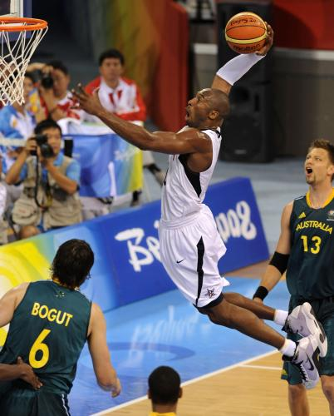
- Minimised our opponents strengths
- Exploited our opponents weaknesses

Our Strengths
- Quick Players
- Centre was a strong rebounder
- Guard was confident, fast dribbler
- Forward was excellent at lay – ups
- Players could cope with skills at a fast pace

Our Weaknesses
- Breaking down defences

Our Opponents Strengths
- Strong zone defence

Our Opponents Weaknesses
- Slow to set up their zone defence
- Slow to get back in their own half
- Poor outside shooters
- Poor rebounders

2.5 STRENGTHS AND WEAKNESSES OF A FAST BREAK

There are many benefits and limitations that teams must consider before applying the fast break strategy.

Strengths of a fast break:
- Fast break creates the easiest way to score
- Attack can take place before the opponents are set to play defence or rebound
- Works well against zone defence due to the time restriction the opponents have for setting up zone
- Creates an easy opportunity to break through the defence (2v1 or 3v2)
- A fast breaking team are better prepared to inbound the ball quickly before a press is set up
- A fast break can cause mismatches against player to player defence
- A fast break team discourages opponents from sending to many players to the offensive board to rebound for fear of not having players to defend
- It motivates a team to play good defence and rebound

Weaknesses of a fast break:
- Could get caught in the opponents half, if the ball is intercepted
- Speed of attack puts pressure on players
- Might not be as effective against man-to-man defence
- Ability levels of players must be high
- Could create a mis-match in opponents favour

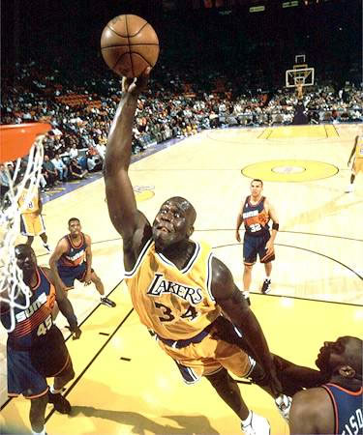

3.1 DEVELOPING PERFORMANCE

In order to make sure your strategy is being performed effectively you will have to highlight any weaknesses/problems with your performance and then develop your strategy to eradicate or improve on any weaknesses that occur. You do this by using the cycle of analysis.

- Investigate - Identify where the problem is occurring.
- Analyse - Highlight the specific weakness in your strategy.
- Develop - Programme of work.
- Evaluate - Monitor/Evaluate strategy to ensure performance remains effective.

1. Identify where the problem is occurring

We would fill out initial data sheets from a video of our performance.

2. Highlight the specific weakness in your strategy

We would then fill out focused data sheets to pinpoint the weakness in the final phase.
Compare our performance to that of a model performance.

3. Programme of work

Once we have discovered where the weakness is we can improve the strategy using a series of drills. Each drill will get progressively more difficult by adding an element of pressure.
(See Development Diagrams)

4. Monitor/Evaluate strategy to ensure performance remains effective

Having improved we would then have to monitor/evaluate our performance to see if our strategy was effective. We would do this by filling out the same initial and focused data collection sheets again. This gives us our comparative data.

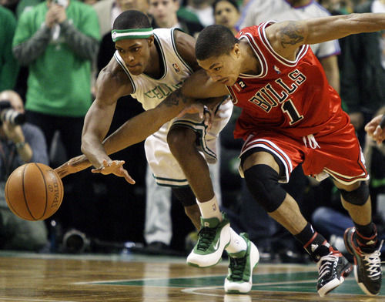

3.2 OUR WEAKNESS

As we can see from our focused data sheets, it is the timing of the run made by the forward that is causing our performance to be ineffective. At this point you can make the decision on what exactly is the problem with the forwards run. You have 2 options.

1. The forward is running in too early
- The passing lane to the forward is cut off and the guard cannot get the ball through for a pass as a defender is in the way. (No width)
- If the forward does manage to receive the pass then he/she is too close to (underneath) the basket to lay-up successfully. The forward would not have enough time to receive the pass, get the ball under control, adjust their hand position and jump for the lay – up.

2. The forward is running in too late
- The guard has to stop and wait on the forward supporting the attack. This allows the defence time to get back and stop the fast break.
- The guard makes the pass too early with the forward too far back and the defence manage to get across and shut down the forward.

3.3 PROGRAMME OF WORK TO DEVELOP AND IMPROVE PERFORMANCE

We planned and carried out a programme of work to develop our performance of the fast break and improve on our weakness of the timing of the forwards run. To begin with so that everyone knew exactly their role and responsibilities, we walked through the fast break option a few times. We then performed it faster and finally performed it at a game pace but with no opposition. The following programme of work ensured practice was game-like and relative to our ability as we progressed through each drill:

- Fast Break Drill – 3V0 (Unopposed)
- Wave Drill – 3V1, 3V2 (Passive)
- 3V2 Pressure Drill
- 3V3 Pressure Drill

Key to Diagrams

= Direction of player without the ball

= Direction of ball

= Direction of dribbler (Player and ball)

= Attacking role

= Defender

3.3 PROGRAMME OF WORK TO DEVELOP AND IMPROVE PERFORMANCE - FAST BREAK
Defensive Phase - The centre collects the rebound and gives a shout to initiate the fast break. He/she then plays an outlet pass to the guard.
Transition Phase - Guard dribbles down the middle of the court as if driving towards the basket. He/she then plays a bounce pass to oncoming forward.
Attacking Phase - The forward collects the bounce pass and drives toward the basket to perform a lay up.
Once the centre has played the outlet pass to the guard in the defensive phase, he/she then runs out wide, behind the guard toward the opponents basket to support the attack. The forward also makes a wide run on the other side of the court. These runs, together with the guard dribbling down the middle of the court, create width in attack. Once the guard has played the bounce pass to the oncoming forward in the transition phase, he/she moves to the top of the key. This creates depth in attack.

3.3 PROGRAMME OF WORK TO DEVELOP AND IMPROVE PERFORMANCE - WAVE DRILL
Aim of Drill – To commit the first defender in a 3v1 or 3v2 Fast Break situation and encourage timing the pass correctly.
Drill Description – Fast break down the court as normal. Guard must drive toward the free throw line to commit the first defender. The guard then makes the pass to the forward for an uncontested lay - up. The drill is repeated.
Extension Drill – A second defender can be added decide who will move toward either the oncoming forward or centre in anticipation of a pass being made. This will encourage the guard to make a quick decision under active pressure based on the actions of the opposition.

3.3 PROGRAMME OF WORK TO DEVELOP AND IMPROVE PERFORMANCE - 3V2 PRESSURE DRILL
Key Concept 3 – Problem solving and decision making when working to develop and improve performance.
Aim of Drill – To make the fast break more game – like by adding active defenders.
Drill Description – The 3 attackers run the Fast Break. As the centre initiates the fast break by shouting rebound, 2 of the defenders run on from opposite corners of the baseline and become active.

3.3 PROGRAMME OF WORK TO DEVELOP AND IMPROVE PERFORMANCE - 3V3 PRESSURE DRILL
Key Concept 3 – Problem solving and decision making when working to develop and improve performance.
Aim of Drill – A game –like practice to promote a quick attack at the basket.
Drill Description – The 3 attackers run the Fast Break. As the centre initiates the fast break by shouting rebound, 2 of the defenders run on from opposite corners of the baseline and become active. As soon as the guard crosses the halfway line with the ball a third defender joins the drill, He/she must touch the centre circle before becoming active.

3.4 ADAPTATIONS BASED ON DEMANDS PLACED ON YOU BY OPPONENTS

During the game, circumstances may occur which require you to adapt or change your strategy. The defence will eventually counter your fast break by tightly/double marking your forward. As a team, using the principle of mobility, you will have to adapt your strategy based on the actions of the opposition. In order to adapt the strategy successfully we must go through three stages:
- Identify what the problem is.
- Make a change to the strategy.
- Monitor/Evaluate adaptation to ensure performance remains effective.

1. Identify what the problem is
We can fill out initial and focused data sheets from a video of our performance. The problem should also be easy to see from the actions of the opposition and by the players communicating with each other during performance. The problem is the opposition are tightly/double marking your forward.

2. Make a change to the strategy
Once we have discovered where the problems are occurring, we can then make a change to our strategy. (See Adaptation Diagrams)

3. Monitor/Evaluate adaptation to ensure performance remains effective
Having made a change to our strategy we would have to monitor/evaluate the adaptation to see if our performance was effective. We would do this by filling out the same initial and focused data collection sheets again. This gives us our comparative data. It should also be easy to see if performance remains effective by looking at the adapted strategy in action. If we begin to get unopposed lay-ups at the basket again then we can deduce that our adapted strategy is successful.

Points to consider
The players must be able to respond to changing situations by adapting team strategies. To be able to adapt, the team must:
- Know the alternatives
- Have practised playing the alternatives against varying defensive situations
- Have practised changing from one strategy to another
- Be able to react on court and under pressure from the opposition

As a result of adapting our strategy:
- We had more options in attack in terms of passing and shooting to ensure that our attack remained mobile.
- We could surprise the opposition and catch them off guard.
- We could put the defenders under pressure.
- We could take advantage of the overload.
- We could retain possession of the ball and not get caught out in attack.

3.4 ADAPTATIONS BASED ON DEMANDS PLACED ON YOU BY OPPONENTS – PASS TO CENTRE (LEFT)

The centre receives the bounce pass from the guard and drives to the basket for the lay – up.

3.4 ADAPTATIONS BASED ON DEMANDS PLACED ON YOU BY OPPONENTS – CROSS OVER & PASS TO FORWARD (LEFT)

The centre and forward cross over after the outlet pass has been made and make wide supporting runs. The forward then receives the bounce pass from the guard on the left hand side and drives to the basket for the lay – up.

3.4 ADAPTATIONS BASED ON DEMANDS PLACED ON YOU BY OPPONENTS – GUARD RECEIEVES PASS BACK FROM FORWARD

The guard receives a pass back from the forward. The guard then has the option to drive to the basket or take a shot from the top of the key.

3.5 ALTERNATIVE STRATEGY – 1 MAN FAST BREAK

As soon as any opposition player has taken a shot, the guard at the top of the key runs hard and fast into the opposition half to receive a long, overhead outlet pass from the centre. The guard then dribbles, unmarked, to the opponents basket for an unopposed lay – up.

3.5 ALTERNATIVE STRATEGY – 1 MAN FAST BREAK

The 1 man fast break is the second option of our offence and can be used under the following situations:

- After a rebound
- After a successful shot

The 1 man fast break allows the ball to be advanced up the court quickly for a high percentage shot (lay – up), by playing a long pass to the guard who has made a break away run. The 1 man fast break is a high risk strategy.

Description of the phases in the 1 man fast break strategy
- Strategy starts at high speed after winning a defensive rebound or a successful shot from the opposition
- As soon as the opposition player shoots, the guard runs hard and fast into the opposition half
- The centre/forward wins the rebound
- The guard signals for a pass
- The centre/forward plays a long, overhead outlet pass to the guard
- The guard collects the pass and dribbles in for an unopposed lay up

Strengths of the 1 man fast break
- Fast break creates the easiest way to score, the lay – up
- Attack can take place before the opponents are set to play defence or rebound
- Creates an attacking overload (1v0)

Weaknesses of the 1 man fast break
- If our team does not win the rebound the opposition have a 3v2 attacking overload
- The guard will tire quickly
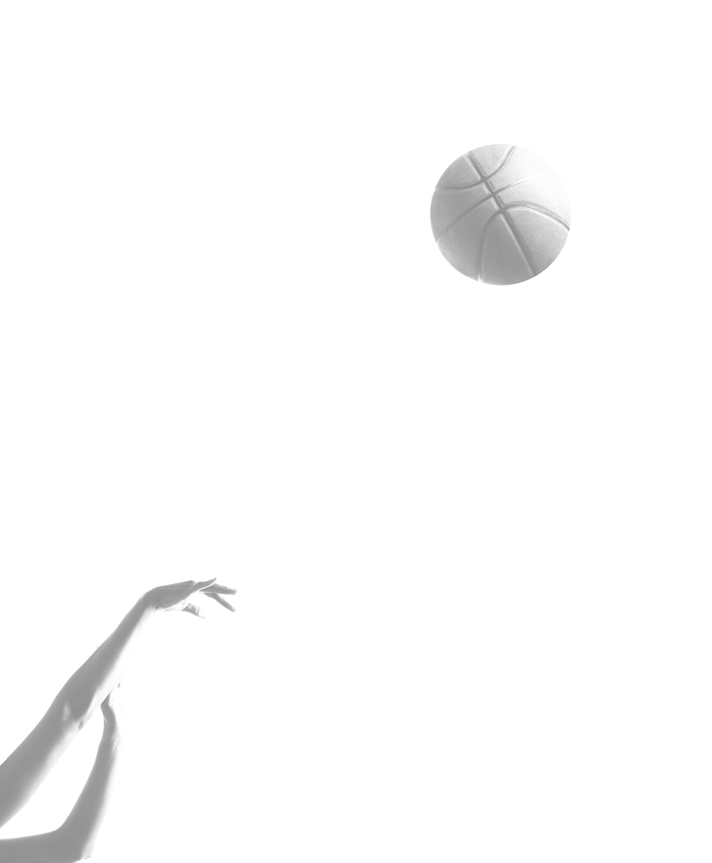
- If the opposition player fakes and our guard runs then the opposition have a 3v2 attacking overload
- The pass from the centre/forward must be accurate and played with the correct weight. This would be difficult when under pressure in the key.

4.1 MONITORING AND EVALUATING

Evaluating performance following a programme of work will ensure the strategy is being performed effectively. When adapting our strategy to meet the new demands placed on us by the opposition, it is also vital to our development that we continually monitor the adaptations made.

Methods used when Monitoring
- Video used with verbal feedback from teacher or coach.
- Knowledge of results – counting the number of baskets scored from a fast break during practice.
- Monitoring the reaction of the defence. If they are coping with the adaptations or adapt their defensive strategy to counter act our new strategy then further changes may be necessary.

Why these methods are appropriate
- Monitoring performance ensures that the adaptations put in place remain effective throughout programme (correct decisions are being made and roles are understood).
- Monitoring performance ensures that players roles are now suited to the adaptations. If not then the players may have to change their role in the attack.
- Can highlight any weaknesses in the adaptations and rectify any problems.

Method used when Evaluating
- Compare performance at start with present.
- Video analysis and the completion of data collection sheets.
- Verbal feedback from teacher or coach.
- Knowledge of results – counting the number of baskets scored from a fast break before and after programme of work/adaptations made.

Why these methods are appropriate
- Repeating the same methods of analysis used before the course of action was carried out allows a comparison of results to be made.
- As the fast break is carried out at a fast tempo, video is useful when completing data sheets as slow motion allows individual players and phases to be observed easily.
- Data collection is an objective and reliable method for monitoring practice as it provides statistical evidence/results on performance. If results are improving, practice is working.
- Knowledge of results allows a quick and easy measurement of our success rate.

NORTHFIELD ACADEMY
PHYSICAL EDUCATION DEPARTMENT

BASKETBALL
STRUCTURES AND STRATEGIES
HIGHER

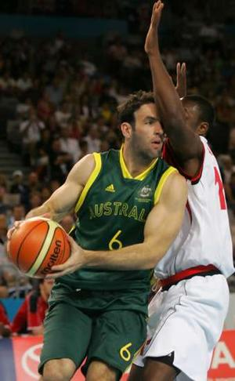

Zone Defence

DEFENCE

A team's success depends on defence. Good defence inhibits your opponents by limiting uncontested open shots. Good team defence not only reduces scoring opportunities for your opponent but opens them to your team. More often than not, steals, interceptions and missed shots lead to high percentage shots at the other end through fast breaks.

Zone Defence

Zone defence is the most energy efficient method of defending in Basketball. Within the "Zone" players can be assigned positions according to their physical attributes and defensive capabilities. Unlike "man to man" defence players are responsible for a specific area of the court which can change at any time depending on factors such as team mates, ball position and opposition.
In order for the zone defence to operate effectively a great deal of cooperation and anticipation of team-mates movements is necessary. In this respect it is not just any team that can turn their hand to defending effectively through use of a "Zone".

X
X
X
X
X
Diagram 1
Diagram 2
X
X
X
X
X

The 2-1-2 Zone Defence The 2-3 Zone Defence

Zone defences are named after the set-up of players from the top of the zone to the basket, for example, 2-1-2 (Diagram 1) or 2-3 (Diagram 2). Other zones include 1-2-2, 3-2, and 1-3-1.

BASIC PRINCIPLES

These are some basic principles employed when playing zone defence:

- Pick your personnel carefully i.e. tall players for rebounding, small quick players on the outside for ball pressure.
- All players should face the ball. They should always know where the ball is and the approximate position of the other players. It is important that the back players communicate and tell the front players the game situation.
- Block the passing lanes, by occupying them or anticipating passes in that area. KEEP HANDS UP AT ALL TIMES TO INTERCEPT STRAY/ POOR PASSES.
- Stop all driving in shots by clogging middle and baseline positions.
- Make sure you always have your rebounding triangle ready to collect missed shots or for interceptions.
- Always look for the fast break as you can always have your outside players (forwards) break away for an outlet pass as soon as the rebound is collected.
- Be sure to get back fast on defence to set yourself up for your zone. ONE PLAYER LAGGING CAN SPOIL YOUR WHOLE DEFENCE AND COST YOU THE GAME.

An Effective Zone Defence –

- Always maintains good shape (stay together).
- Does not get broken down easily.
- "Help and Recover" is provided - zone will momentarily break shape in order for one player to help another team-mate and prevent a potentially penetrating pass or aggressive dribble and then recover back to their correct position within the zone.
- Force shots from outside the zone near the 3 point line that will have lower success rate than lay up shots.
- Will wear teams down, in extreme cases meaning no shot at all from the offensive team. (Remember no shot within 24 seconds means your team loses the ball).
- As well as the above, a zone defence must also have players in the correct positions, according to the type of zone you are playing.

Positioning

Within a zone defence players can be assigned positions according to one or more of the following:-

- Physical Qualities/Attributes - Height or Speed.
- Personal Qualities - Good leadership skills, good communicator, organises well.
- Technical Qualities - Defensive Capabilities (Good rebounding ability)

STRENGTHS AND WEAKNESSES

Every zone defence has its own strengths and weaknesses. Common to all are the following:

Strengths

- Protects the inside of the Key against a team with good drivers and fast players and poor outside shooters.
- Defensive players can be assigned positions according to their height and defensive capabilities I.e. taller players can be assigned to areas inside the key for rebounding and for trying to block shots at the basket. Smaller, quicker players can be assigned to outside areas for putting pressure on the ball and covering the lanes.
- Players are in a tactically more structured and balanced initial position for starting a fast break than they would be if they were playing man to man. Therefore as well as being a sound defensive strategy the zone defence also has positive implications for a teams offensive game.
- The "Zone" is more effective than man to man defence against teams with good "cutting and screening" offensive manoeuvres. For instance, within man to man defence, players are more easily manipulated and dragged into areas of the court they would not normally be in. This in turn can create space for the offensive team. This does not occur as often when a team plays a "zone" defence as players are responsible for an area of the court/space and not an opposing player.
- The zone defence is fairly easy to learn and may overcome an individual's weakness in basic defensive skills.
- Players who are in danger of being "fouled out" can be protected within a zone defence. I.e. A defensive players' position can be changed if an offensive player is giving him/her a lot of problems and inviting/enticing a lot of fouls.
- A team’s ability to change to a zone defence during a game can disrupt any positive rhythm that the opposing team may have built up.

Weaknesses

Zone Defence can be ineffective when:

- If the opposing team have strong shooters and are successful from outside the key.
- If the opposing team have a good fast break the Zone won't have time to set up.
- Quick passing moves the ball quicker than Zone defenders can shift.
- The opposing team are ahead so they can 'stall' more easily against the Zone by passing round it. This may have a tendency for the Zone to 'break up' as individual players try to move to get the ball.

2-1-2 ZONE DEFENCE FORMATION

The 2-1-2 defence is one of the most frequently used zones in basketball.

Consider the following roles of players within a 2-1-2 zone defence.

Key:
F - Forward
C - Centre
G - Guard
F
G
F
C
G

- In a 2-1-2 zone defence, each player has responsibility to mark a particular area within the zone.
- The zone defends the area close to the basket and makes it difficult for opponents to take a shot inside the key.
- Shots tend to come from outside the key.
- Three players have formed a defensive triangle closest to the basket. If a shot is missed the defence should be in a good position to collect the rebound.
- When the ball is played from one side of the court to the other side the zone must shift position.
- Players within the zone should put opponent closest to them under pressure.

Roles and Relationships

- Guards, playing at the front of the zone, use their quickness and mobility to pressure the ball at the top and sides of the key. Guards are also in an ideal position to break quickly into offence.

- Forwards, playing on the baseline at the edge of the key, pressure shooters from the side and rebound after a shot.

- The centre, playing in the middle of the key, uses height to prevent a drive to the basket and act as the main defensive rebounder.

TEAM PRINCPLES – 2-1-2 ZONE DEFENCE

Zone defence will require the team principles of width, depth, mobility, support and pressure. Team principles will change depending on the type of strategy played. Within zone defence a variety of different tactical elements can be used.

1. 2-1-2 Zone

2. 1-2-2 Zone

3. 1-3-1 Zone

4. 2-3 Zone

Again we will look at the 2-1-2 zone.

Team principles

- The offence is allowed to come into our half, just outside the three point line, before any pressure is applied. It gives us the opportunity to re-group at half way after our opponents have regained the ball.
- Guards at the front of the zone need to move quickly to put the outside shooters under pressure. They need to react to quick passes across the zone.
- We reduce the width of the court we are defending and if we make a mistake another player is not too far away to help.
- The zone needs mobility to shift from one side of the key to the other.
- When a shot is taken players at the basket can support each other by forming a defensive triangle.

Strengths of a 2-1-2 zone

- Good starting position for a fast break when the ball is intercepted
- Area around the basket is closely defended
- Good positioning for rebound

Weaknesses of a 2-1-2 zone

- The strategy allows some outside shots. If the opposition have high percentage outside shooters the zone will be limited in its effectiveness.
- A tall team may still be able to rebound against us.
- If the zone is too slow to shift as a unit, the opposition will be able to create space both inside and outside the key.
- The zone does not put players bringing the ball up the court under pressure. The offence has time to set up their strategy.

PRINCIPLES USED AGAINST A ZONE DEFENCE

A good offensive team will do its best to break down your zone. They will employ these basic points to make sure they are successful in their offence and score as many baskets as possible.

- They will try and find out if you are playing a zone defence. They do this by sending a man through the middle of your defence. If he is not picked up then it is a zone. They will then try to find out which kind of zone it is, for example 2-1-2.
- Pick there spots for shooters, passers and rebounders.
- They will not force there shots or passes and will try to make shots successful and passes accurate.
- Will not play lob or cross court passes that could be intercepted and allow you to make a fast break up the court.
- Will try to create 2v1 and 3v2 situations to break down the zone and create spaces within the zone for scoring opportunities.

If the offensive team are successful at breaking down your zone then it maybe the case that you have to adapt or vary your defensive strategy.

ADAPTING STRATEGIES

As play continues it may be necessary to change or adapt your strategy in response to performance demands. The need to change or adapt current strategy will depend on the following types of offensive and defensive considerations.

- The strategy is working or not.
- Adjusting defence rhythm to upset the offence.
- To catch up or to exert even more pressure.
- Whether the individual / team is in ‘foul’ trouble.
- To suit individuals in key positions.
- To pressurise key players in the opposition.
- The physical demand of the adopted strategy.
- The time is running out.
- You are being winning/losing.

Points to consider

The players must be able to respond to changing situations by adapting team strategies. To be able to adapt, the team must:
- Know the alternatives.
- Have practised playing against varying offensive / defensive structures
- Have practised changing from one strategy to another.
- Be able to react on court.

MAN TO MAN (MATCH UP) DEFENCE

As described on the previous page, such a change may be from a Zone Defence to a Man to Man (match up) Defence. Let us look at that defence as an option.

Formation

Consider the following roles of players within a man to man defence.

Key
A - Attacker
D - Defence

A
D

A D
D A

A D
D A

- In a man to man defensive set up, each player has responsibility to mark a particular opponent. When the opponent moves into an attacking position you continue to move with them, staying between ball and basket.
- A 'match up' should take place at the start of the game. This would mean players marking opponents with similar qualities i.e. tall players mark tall players, fast mobile players mark fast mobile players (you do not need to mark a player that plays the same position but this is very common).
- Principle of 'help' defence. If, while playing, your team-mate has lost their offensive opponent (who is in possession of the ball) another defender must come across to help out. This will hopefully, prevent an easy basket.
- Team mates must communicate with each other defending, identifying when help is required.
- Opponents should find it difficult to shoot as our defenders are close to them, putting them under pressure.

Roles and Relationships

- Guards use their quickness and mobility to pressure the ball (particularly the ball handler), deny the pass and play help defence.
- Forwards dent the pass, play help defence and prevent free shoots from outside. They also need to rebound after a shot.
- Centre uses height to deny the pass into the post, step into the key to play help defence and is the main defensive rebounder.

TEAM PRINCPLES – MAN TO MAN

Man to man defence will require the team principles of width, depth, delay, mobility, support and pressure. Team principles will change depending on the strategy played. Within man to man defence three tactical elements can be used.

- 1/2 court man to man
- 3/4 court man to man
- Full court man to man

We will only look at 1/2 court man to man defence.

Team Principles

- The offence is allowed to come into our half before any pressure is applied. It gives us the opportunity to re-group at half way after our opponents have regained the ball.
- If the player with the ball drives to the basket and 'loses' their defender we will be in a position to play help defence. Defenders are still quite close to each other and those in a deeper position can step in to help. This provides support for our team-mates.
- We can use the width of the court to push the offence to the side and away from the danger areas.
- Pressure can be applied to offensive players forcing mistakes. The player dribbling the ball can be pushed to their weaker side, while those off the ball can be guarded closely. By using this defensive mobility (to deny the pass), passing between players can be difficult for the offence.

Strengths of Man to Man

- Definite responsibility for each player
- Possible to match opponents for size, speed and ability
- It is easy to see who is falling down in defence
- Only possible defence to use when wanting to force play when your team is behind.

Weaknesses of Man to Man

- If our team does not play help defence then the opposition will get easy drives at the basket.
- May not prevent the outside shot if opposition run a successful play against us.
- If they are a taller team mismatches will occur. The opposition will then post up against our team and shoot from close to the basket.
- If dragged out of position, there will not be enough defensive rebounds.
- Very demanding physically - Demands fitness and skill.
- Draws more fouls

RULES

Starting/ Restarting
- The start of a basketball game is called a Tip Off. This is when two opponents jump to win possession of the ball at the centre circle. The players jump for the ball and attempt to tip the ball to a team-mate.
- Once a team has scored a basket the game is restarted by the team who conceded the basket. A player from that team throws the ball back into play from behind the baseline, underneath the basket.
- If a rule has been broken by a team, their opponents restart the game by throwing the ball back into play from behind the sideline. This is known as a side ball.

Safety
- Basketball is a non contact activity. Each player has his/ her personal space which, if another players breaks by making illegal contact with an opponent, a foul is awarded.
- If this illegal contact is made when the player who is fouled is attempting a shot, (fouled in the act of shooting), then free throws are awarded.
- If this illegal contact is made when the player who is fouled is not shooting then a side ball is awarded.

Scoring
- Successful free throws are worth 1 point each.
- A successful shot taken from inside the ‘D’ is worth 2 points.
- A successful shot taken from outside the ‘D’ is worth 3 points.

Restricting Movement
- Travelling. A player cannot run with the ball unless they are dribbling. A player holding the ball in two hands after a dribble can pivot using either foot as their pivot foot. A player taking more than 2 steps with the ball in their hands is committing a travelling violation.
- Double Dribble. A player can dribble the ball using 1 hand only. To change hands the dribbler must bounce the ball to the other hand. After completing a dribble i.e. collecting the ball in two hands, a player my not dribble again. A player dribbling with 2 hands or completing a dribble and dribbling again is committing a double dribble violation.
- If a player commits a travelling or double dibble violation then a side ball is awarded to the other team.

Fouls
- Individual fouls. A player will leave the court after they commit five fouls.
- Team fouls. If a team commits more than seven fouls in one half then the opposition will be awarded two free throws every time a foul is committed after the seventh.

Time
- The length of a time-out is 1 minute. 50 seconds is given to discuss and make role changes and 10 seconds is allocated to get back on court to restart the game.
- Once team gain control, they have 24 seconds to shoot or the opponents receive the ball.
- A team has 10 seconds to get the ball out of their half once they have gained possession.
- A player has 5 seconds to dribble/pass/shoot once they have collected the ball in two hands.
- A player has 5 seconds to ‘inbound’ the ball when a foul has been committed or the ball has gone out of play.
- An attacking player can only stand in the ‘key’ for 3 seconds at a time.
- If any of these time rules are broken a side ball is awarded to the opposition.

GLOSSARY OF TERMS

- Assist – A pass which leads directly to a pass being scored
- Backcourt – The half of the court containing the team’s own basket
- Baseline – The end line of the court, 1.2 metres behind the backboard
- Basket – The target and the name for a scoring shot
- Centre – The tallest player in the team, a shot blocker and the leading rebounder who scores most of his or her points closest to the basket
- Defence – Individual and team moves that defend your basket
- Fakes – Pretending to pass, shoot or dribble to force a defender off balance
- Fast Break – A quick attack executed before the opposition take up their defensive position
- Foul line – The line from which free throws are taken
- Free Throw – Awarded after a team has passed the number of team fouls allowed. Taken unopposed from the foul line and worth one point
- Front court – The half of the court containing the basket which a team attacks
- Inbound – Putting the ball into play
- Inside – Close to or under the basket
- Jump shot – One handed shot released at the top of a jump
- Key – Can be used to describe the lane, the area marked out on the court floor from the baseline to the foul line
- Lay-up – One handed shot delivered at the end of a run either directly into the basket or, usually, off the backboard
- Offence – Individual and team moves that attack the opponents basket
- One on One – One offensive player against one defensive player
- Controlling the boards – Gaining the majority of the rebounds
- Cut – A quick movement by an offensive player without the ball to gain advantage over the defence, usually directed towards the basket
- Drive – The movement of an offensive player while aggressively dribbling towards the basket in an attempt to score
- Forward – The name of a position in the team. The forwards on offence in the area of the court, either on the right or the left hand side, between the restricted area and the sideline
- Outlet Pass – The pass made by a player after he has taken the defensive rebound
- Point guard – The ball handler, play maker or floor general of the team. An excellent passer. The point is the position in the middle of the offence. The player at point need not necessarily have the ball
- Press – Playing pressure defence over the full court length
- Rebound – When the ball bounces from the backboard or the ring
- Screen – Offensive player without the ball blocking the path of a defender who is chasing the dribbler or another offensive player without the ball
- Steal – Taking the ball away, legally, from an opponent’s hands
- Time-out – Each coach may call two time-outs each half and a further one in each period of overtime. A time-out lasts for one minute
- Travelling – An illegal dribble caused when the player fails to bounce the ball correctly
- Give and Go – An offensive manoeuvre in which a player passes the ball to a team mate and cuts towards the basket for a return pass
- Options – Alternative offensive manoeuvres that can occur in a game situation
- Elbow – The point where the free throw line meets the side of the key.

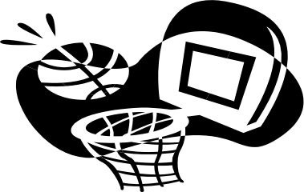
BRIDGE of DON ACADEMY
Performance Marking Guidelines
Basketball – Intermediate 2

A B C

20 | 19 | 18 | 17 | 16 | 15 | 14 | 13 | 12 | 11
GRADE A  Candidates should demonstrate some control and fluency in a variety of skills and techniques and apply these skills and techniques in a game situation.  Candidates should also demonstrate an understanding of situations in the game and show awareness of team-mates and opposition. |  |  | GRADE B  Marks in the middle range should be awarded where the assessor judges that the candidate’s performance is above minimum competence but is not yet reflecting the full qualities associated with the Grade description for A (Int 2). |  |  |  | GRADE C  Marks in the lower range should be awarded where competence at this level is acknowledged in the assessor’s evaluation of ‘live’ performance (taking account of all PCs, notes on range/Grade description for C (Int 2).
GRADE A:  Consistent level of dribble/control.  Accurate shooting using a range of techniques according to the context of play.  Accurate passing, using a range of techniques.  Can manoeuvre off the ball and utilise space in a games context in both offence and defence.  Can combine skills effectively in a games context involving a variety of options.  Can show some awareness of team-mates and opposition and make the correct decisions relating to the context of play. |  |  | GRADE B:  Students should be demonstrating the majority of the skills within ‘Grade A’.  The consistency of skill level has not been as apparent and the student has not demonstrated a consistency in their ability to combine/ carry out skills effectively under pressure from opposition. |  |  |  | GRADE C:  Students should be demonstrating a selection of skills within ‘Grade A’, however, students lack consistency in their skill level, consistency, spatial awareness and decision making.

BRIDGE of DON ACADEMY
Performance Marking Guidelines
Basketball – Higher

A B C

20 | 19 | 18 | 17 | 16 | 15 | 14 | 13 | 12 | 11
GRADE A  Candidates should demonstrate control and fluency across a range of skills and techniques and apply these skills and techniques under pressure from opponents and at a fast tempo.  Candidates should also demonstrate an understanding of situations in the game and how best to adapt/ refine their play to overcome a given situation. |  |  | GRADE B  Marks in the middle range should be awarded where the assessor judges that the candidate’s performance is above minimum competence but is not yet reflecting the full qualities associated with the Grade description for A (H). |  |  |  | GRADE C  Marks in the lower range should be awarded where competence at this level is acknowledged in the assessor’s evaluation of ‘live’ performance (taking account of all PCs, notes on range/Grade description for C (H).
GRADE A:  Consistent high level of dribble/control.  Consistent accurate shooting using a range of techniques according to the context of play.  Consistent and accurate passing, using appropriate technique for context of play.  Can consistently manoeuvre off the ball, utilise space and create space in a games context in both offence and defence.  Can adapt and combine skills effectively in a games context involving a wide variety of options including pressure situations and changing strategies.  Can show an awareness of team-mates and make the correct decisions relating to the context of play. |  |  | GRADE B:  Students should be demonstrating the majority of the skills within ‘Grade A’.  The consistency of skill level has not been as apparent and the student has not demonstrated a consistency in their ability to combine/ carry out skills effectively under pressure from opposition. |  |  |  | GRADE C:  Students should be demonstrating a selection of skills within ‘Grade A’, however, students lack consistency in their skill level, spatial awareness and decision making.

