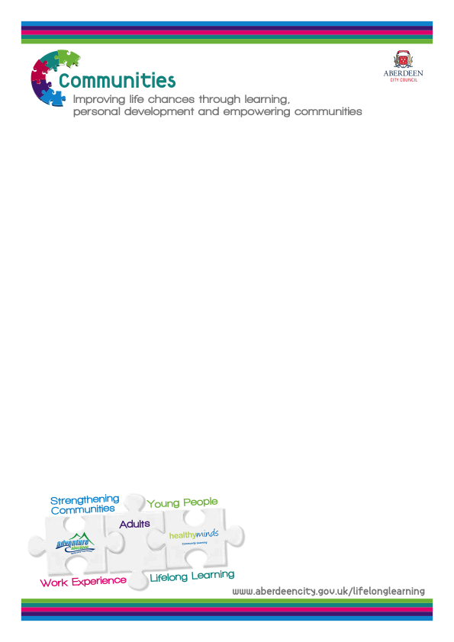

Digital Access in Aberdeen

Digital Access in Aberdeen

- Where can I get access to computers and the internet?
Organisation | When | Information
Star Community Flat  14A Seaton Drive, Aberdeen, AB24 1UX  01224 524209 | Monday to Friday  10.00 am – 2.00pm
Airyhall Library,  Springfield Road,  Aberdeen AB15 7RF  01224-310536  AiryhallLibrary@aberdeencity.gov.uk | Monday  10.00 am – 7.00 pm  Tuesday  10.00 am – 5.00 pm  Wednesday  10.00 am -7.00 pm  Thursday to Friday  10.00 am – 5.00 pm  Saturday  10.00 am – 1.00 pm,  2.00 pm – 5.00 pm | Adult PCs -7
Bridge of Don Library,  Scotstown Road,  Bridge of Don,  Aberdeen AB22 8HH  01224-702800  BridgeOfDonLibrary@aberdeencity.gov.uk | Monday  10.00 am - 7.00 pm  Tuesday  10.00 am – 5.00 pm  Wednesday  10.00 am – 7.00pm  Thursday to Friday  10.00 am – 5.00 pm  Saturday  10.00 am -1.00 pm,  2.00 pm – 5.00 pm | Adult PCs – 6
Bucksburn Community Library,  Kepplehills Road,  Aberdeen AB21 9DG  01224 710830  BucksburnLibrary@aberdeencity.gov.uk | Monday  2.00 pm - 7.00 pm  Tuesday  10.00 am -1.00 pm,  2.00 pm - 5.00 pm  Wednesday  2.00 am - 7.00 pm  Thursday to Friday  10.00 am – 1.00 pm,  2.00 pm - 5.00 pm  Saturday  10.00 am – 1.00 pm | Adult PCs – 12

- Where can I get access to computers and the internet?
Organisation | When | Information
Central Library  Rosemount Viaduct  Aberdeen  AB25 1GW  01224 652500  CentralLibrary@aberdeencity.gov.uk | Monday  9.00 am – 8.00 pm  Tuesday  9.00 am – 5.00 pm  Wednesday  9.00 am – 8.00 pm  Thursday to Saturday  9.00 am – 5.00 pm | Adult PCs – 31  PCs 1-12 are only available when a College Class is not in progress.
Cornhill Library,  Cornhill Drive,  Aberdeen AB16 5UT  01224-696209  CornhillLibrary@aberdeencity.gov.uk | Monday to Wednesday  10.00 am -1.00 pm,  2.00 pm - 5.00 pm  Thursday to Friday  1.00 pm – 5.00 pm  Saturday  10.00 am – 1.00 pm | Adult PCs – 4
Cove Library,  Loirston Avenue,  Aberdeen AB12 3HE  01224 245350  CoveLibrary@aberdeencity.gov.uk | Monday  2.00 pm – 7.00 pm  Tuesday  9.30 am – 1.00 pm,  2.00 pm – 5.00 pm  Wednesday  2.00 pm – 7.00 pm  Thursday  9.30 am - 1.00 pm,  2.00 pm – 5.00 pm  Friday  9.30 am – 1.00 pm,  2.00 pm – 5.00 pm  Saturday  9.30 am – 1.00pm | Adult PCs – 8
Culter Library,  North Deeside Road,  Aberdeen AB14 0UJ  01224 732587  CulterLibrary@aberdeencity.gov.uk | Monday  2.00 pm – 7.00 pm  Tuesday  10.00 am – 1.00 pm,  2.00 pm – 5.00 pm  Wednesday  2.00 pm – 7.00 pm  Thursday to Friday  10.00 am – 1.00pm,  2.00 pm – 5.00 pm  Saturday  10.00 am - 1.00 pm | Adult PCs – 5

1. Where can I get access to computers and the internet?
Cults Library & Learning Centre,  429 North Deeside Road,  Aberdeen AB15 9SX  01224 868346  CultsLibrary@aberdeencity.gov.uk | Monday  2.00 pm – 7.00 pm  Tuesday  10.00 am - 1.00 pm,  2.00 pm – 5.00 pm  Wednesday  2.00 pm – 7.00pm  Thursday to Friday  10.00 am – 1.00 pm,  2.00 pm – 5.00 pm  Saturday  10.00 am – 1.00pm | Adult PCs – 10
Ferryhill Library,  Fonthill Road,  Aberdeen  AB11 6UP  01224 581576  FerryhillLibrary@aberdeencity.gov.uk | Monday  1.00 pm – 7.00pm  Tuesday  10.00 am – 5.00 pm  Wednesday  1.00 pm – 7.00 pm  Thursday to Friday  10.00 am – 5.00 pm  Saturday  10.00 am – 1.00 pm | Adult PCs – 6
Kaimhill Library,  Pitmedden Terrace  Aberdeen AB10 7HR  01224-498160  KaimhillLibrary@aberdeencity.gov.uk | Monday  2.00 pm – 7.00 pm  Tuesday  9.00 am – 12.00 pm,  2.00 pm – 5.00 pm  Wednesday  2.00 pm – 7.00 pm  Thursday  9.00 am – 12.00 pm,  2.00 pm – 5.00 pm  Friday  1.00 am – 5.00 pm  Saturday  10.00 am – 1.00 pm | Adult PCs – 15

1. Where can I get access to computers and the internet?
Kincorth Library,  Provost Watt Drive  Aberdeen AB12 5NA  01224 872572  KincorthLibrary@aberdeencity.gov.uk | Monday  9.00 am – 7.00 pm  Tuesday to Friday  9.00 am – 5.00 pm  Saturday  10.00 am – 1.00 pm | Adult PCs – 5
Mastrick Library,  Greenfern Road,  Aberdeen AB16 6TR  01224 788558  MastrickLibrary@aberdeencity.gov.uk | Monday  10.00 am – 7.00 pm  Tuesday  10.00 am – 5.00 pm  Wednesday  10.00 am – 7.00 pm  Thursday to Friday  10.00 am – 5.00 pm  Saturday  10.00 am – 1.00 pm,  2.00 pm – 5.00 pm | Adult PCs – 6
Northfield Library,  Byron Square,  Aberdeen AB16 7LL  01224-695104  NorthfieldLibrary@aberdeencity.gov.uk | Monday  2.00 pm – 7.00 pm  Tuesday  10.00 am – 1.00pm,  2.00 am – 5.00 pm  Wednesday  2.00 am – 7.00pm  Thursday  10.00 am – 1.00 pm,  2.00 pm – 5.00 am  Friday  10.00 am – 1.00 pm,  2.00 am – 5.00 pm  Saturday  10.00 am – 1.00 pm | Adult PCs – 3

- Where can I get access to computers and the internet?
Organisation | When | Information
Tillydrone Library & Learning Centre,  Pennan Road,  Aberdeen AB24 2UD  01224 276975  TillydroneLibrary@aberdeencity.gov.uk | Monday  10.00 am – 7.00 pm  Tuesday  10.00 – 5.00  Wednesday  10.00 am – 7.00 pm  Thursday to Friday  10.00 am – 5.00 pm  Saturday  10.00 am – 1.00 pm | Adult PCs – 12
Torry Library,  Victoria Road,  Aberdeen AB11 9NJ  01224 879037  TorryLibrary@aberdeencity.gov.uk | Monday  2.00 pm – 7.00 pm  Tuesday  10.00 am – 1.00 pm,  2.00 pm – 5.00 pm  Wednesday  2.00 pm – 7.00 pm  Thursday  10.00 am – 1.00pm,  2.00 pm – 5.00 pm  Friday  10.00 am – 1.00 pm,  2.00 pm – 5.00 pm  Saturday  10.00 am – 1.00 pm | Adult PCs – 7
Woodside Library,  356 Clifton road,  Aberdeen AB24 4DX  01224-484534  WoodsideLibrary@aberdeencity.gov.uk | Monday  2.00 pm – 7.00 pm  Tuesday  10.00 am – 1.00 pm,  2.00 pm – 5.00 pm  Wednesday  2.00 pm – 7.00 pm  Thursday  10.00 am – 1.00 pm,  2.00 pm – 5.00 pm  Friday  10.00 pm – 1.00 pm,  2.00 pm – 5.00 pm  Saturday  10.00 am – 1.00 pm | Adult PCs – 3

2. Where can I find classes to learn how to learn to use a computer?
Organisation | When | Information
Kincorth Community Centre  Beginners Computing Class  01224 346447 | Monday  9.30 am -12.00 pm | Classes are run by Adult Learning
Tullos Community Centre  Beginners Computing Class | Monday  10.00 am - 12.00 pm | Classes are run by Adult Learning
Seaton Hut  Beginners Computing Class | Monday  12.30 am – 2.30 pm | Classes are run by Adult Learning
Beginners Computing Class  Woodside Fountain Community Centre, Marquis Road, Woodside, Aberdeen, AB24 2QY | Monday  1.00 am – 3.00 pm | Classes are run by Adult Learning
Beginners Computing Class  Mastrick Community Centre | Monday  12.00 am – 2.00 pm | Classes are run by Adult Learning
Open Drop-in  Tillydrone Community Flat  Alexander Terrace | Monday  3.00 pm - 4.00 pm | Classes are run by Adult Learning
Intermediate Computing  Kincorth Community Centre | Tuesday  10.00 am - 12.00 pm | Classes are run by Adult Learning
Beginners Computing  Torry Youth and Leisure Centre | Tuesday  10.00 am -12.00 pm | Classes are run by Adult Learning
Intermediate Computing  Kincorth Community Centre | Tuesday  10.00 am - 12.00 pm | Classes are run by Adult Learning
Beginners Computing  Woodside Fountain Community Centre, Marquis Road, Woodside, Aberdeen, AB24 2QY | Tuesday  10.00 am - 2.00 am | Classes are run by Adult Learning
Beginners Computing  Woodside Fountain Community Centre, Marquis Road, Woodside, Aberdeen, AB24 2QY | Tuesday  10.00 am - 2.00 pm | Classes are run by Adult Learning
Beginners Computing  Torry Youth and Leisure Centre | Tuesday  12.30 am - 2.00 pm | Classes are run by Adult Learning

2. Where can I find classes to learn how to learn to use a computer?
Organisation | When | Information
Beginners Computing  Cummings Park Community Centre | Wednesday  10.30 am -12.30 pm | Classes are run by Adult Learning
Beginners Computing  Seaton Hut | Wednesday  11.00 am – 12.00 pm | Classes are run by Adult Learning
Intermediate Computing  Bucksburn Community Centre | Wednesday  10.00 am – 12.00 pm | Classes are run by Adult Learning
Beginners Computing  Mastrick Community Centre | Thursday  9.30 am – 11.30 pm | Classes are run by Adult Learning
Job Club  Central Library | Thursday  10.00 am -12.00 pm | Classes are run by Adult Learning
Job Club  Central Library | Thursday  1.00 am -3.00 pm | Classes are run by Adult Learning
Beginners Computing  Hanover Community Centre | Friday  9.30 am – 10.00 pm | Classes are run by Adult Learning
Beginners Computing  Star Community Flat  14A Seaton Drive, Aberdeen, AB24 1UX  01224 524209 | Friday  10.00 am – 12.00 pm | Classes are run by Adult Learning
WEA Reach Out  163 King Street  Aberdeen  AB24 5AE  01224 640811  reachout@weascotland.org.uk | Monday to Friday  9.00 am - 4.30 pm | We facilitate groups for those with no IT skills or for those who simply want to ‘refresh’. It is a basic IT course and as it says on the tin, goes right back to basics. We have set times for the course and it is based over a ‘term’. We run 3 terms a year. We also have an IT drop in and an employability course where we help with Cvs and cover letters

3. Where can I find public access Wi-Fi?
Organisation | When | Information
Aberdeen Maritime Museum,  Shiprow, AB11 5BY  01224 337700 | Monday to Saturday  10am-5pm  Sunday  12.00 pm – 3.00pm
Seventeen  17 Belmont Street, AB10 1 JR  01224 644885 | Tuesday  10.00 am – 17.00 pm  Wednesday  13.30 pm – 17.00 pm  Thursday  10.00 am – 17.00 pm  Friday  10.00 am – 17.00 pm  Saturday  10.00 am – 16.00 pm
Adventure Aberdeen,
Fairley Road, Kingswells, AB158PZ
01224 270990
Marischal College Customer Access Point,  Ground Floor, Marischal College, Broad Street, AB101AB  01224 219283 | Monday to Friday  8.30 am – 5.00 pm
Aberdeen Sports Village  Linksfield Road, Aberdeen,  AB24 5RU | Monday to Friday  6.30 am - 10.30pm  Saturday  7.30 am - 7.30pm  Sunday  7.30am - 9.30pm
Rosemount Learni ng Centre, Belgrave Terrace, Aberdeen, AB25 2NS  01224 647594 | Monday to Friday  9.00 am – 5.00 pm
Froghall Community Hall,
Powis Terrace, Aberdeen,
AB25 3TX
01224 640435
Dyce Community Learning Centre,  Gordon Terrace, Aberdeen, AB21 7BD  01224 723344 | Monday to Friday  9.00 am – 5.00 pm
Cummings Park Community Centre,  Cummings Park Crescent, Aberdeen, AB16 7AS,  07765 972812 | Monday to Friday  9.30am - 1.30pm  5.00pm - 9.30pm

3. Where can I find public access Wi-Fi?
Organisation | When | Information
Torry Youth and Leisure Centre, Oscar Road, AB11 8ER  01224 878927 | Monday to Friday  9.00 am – 5.00 pm
Woodside Fountain Community Centre, Marquis Road, Woodside, Aberdeen, AB24 2QY  01224 524926 | Monday to Friday  9.00 am – 6.00 pm
Lord Provost Henry E Rae Community Centre, Middlefield Parish Church , Aberdeen, AB25 2NS
01224 662792
Tullos Community Learning Centre, Girdleness Road, Aberdeen, AB24 2QY  01224 291882 | Monday to Friday  9.00 am – 5.00 pm
4. Where can I get help with purchasing printers and laptops at a reduced cost?
Organisation | What | Information
North East Credit Union ,  7 Finnan Place , Aberdeen, AB11 8RG  01224 899688 | NESCU offers members a digital inclusion instant loan £321.60 with a £30 deposit. This enables the purchase of a HP250 laptop, Cannon Printer and laptop bag. | To qualify for this offer you need to be a member of the Credit Union and save while repaying the loan.

