BRIDGE OF DON ACADEMY

How can parents/carers support learning?

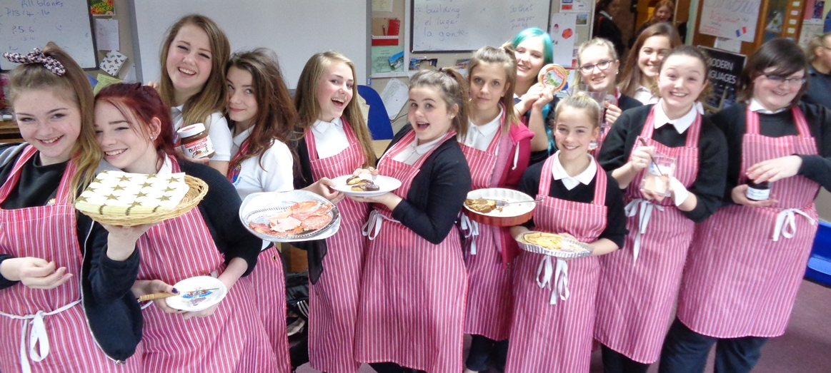
Cafe Français with a continental twist………….

How can parents/carers support learning?

Ready to Learn
When you send your children to school ready to learn it is one of the most important things you can do, as a parent. Young people learn best when they have had enough sleep and enough to eat to give them the energy to get through the first part of the day. Bringing the right equipment and wearing school uniform shows their teachers that they take their learning seriously and are ready for work not play and begins the process of self-discipline required for life beyond school

Learning to Learn
For some young people learning seems to come very naturally. We all know people who seem to be able to understand complex subjects that baffle us and grasp new ideas quickly and with ease. They remember the key facts and seem to be able to recall them later with little effort. For most of us learning is hard work and a little bit messy. The path to success is often very bumpy and two steps forward can often be followed by a period of what can feel like standing still or even going backwards!

Every time you encourage your children not to give up you are doing something very positive to help them learn. The most successful people in life are those who don’t give up even when things are really difficult. This quote from Michael Jordan, the famous American Basketball player, sums this up beautifully.

I've missed more than 9000 shots in my career. I've lost almost 300 games. 26 times, I've been trusted to take the game winning shot and missed. I've failed over and over and over again in my life. And that is why I succeed.

We are not suggesting that you force your children to continue with a hobby or interest that they no longer enjoy or have outgrown. But every time you encourage your children to keep trying with something that is difficult you are supporting the development of perseverance and resilience both of which are essential qualities for success.

Learning New Skills
Skills for Life, Learning and Work
When you remind your children that skills are important and that employers value skills as much as knowledge then you are supporting their learning. We want all of our young people to grow in confidence, take increasing responsibility as they mature and be able to contribute to the life of the school and other groups they belong to. Our Core Skills framework is what teachers use to plan learning to ensure that pupils have appropriate opportunities to develop and apply these important skills. This framework covers Communication Skills, Thinking Skills and Personal and Interpersonal Skills.

Communication Skills
When you talk to your children and remind them of the importance of communication you are supporting the development of a vital skill. All young people have to be able to communicate with peers, teachers and other adults both verbally and in writing. When you encourage your child to explain things to you and offer to read over their work you are supporting the development of their communication skills. For example when your child asks you or agrees to let you read over their work ask them if they would like you to correct work for errors in spelling, grammar and punctuation or to give feedback on the content. That way you give them some control over their work and the feedback you give them. It is also good if you can find one or two things that you can give positive feedback on and one suggestion for improvement. For example you could ask them to explain specialist vocabulary or a term that is being used in the subject.

If young people have a presentation or talk to deliver you can offer to listen to it and encourage them to use eye contact to engage the audience and to refer to notes as little as possible. If they are using PowerPoint please remind them that slides should be prompts for them to explain or talk about and should not be read out word for word.

But most of all encourage your child to be tolerant of the views of others and to communicate their own opinions and ideas calmly at the same time as understanding that not everyone else will share their views.

Do not underestimate the skills that can be developed by discussions at home on news items or events in the world. Good debating and discussion skills always begin at home. When strong views are held they should be backed up by evidence and so when you encourage your child to support their views with evidence you are showing them that opinion needs to be backed up by the facts.

Thinking Skills
Sometimes young people just want us to tell them the answer. But, when you encourage your child by asking them to think about a solution to a problem or ask them to suggest ways they could find the answer then you are encouraging them to become independent learners and so they will mature and develop their confidence. Our curriculum is designed to give young people the chance to think things out for themselves. Our society needs citizens who can solve problems, apply their learning to unfamiliar situations and think creatively to solve problems. Our teachers are constantly working on their questioning techniques so that they encourage pupils to think things out and they are not just given the answers. If your child asks a question try reframing it and asking them what they think the answer is. If it is a factual question ask them where they could find the answer and how would they know whether the information they found was reliable.

The internet is a great source of factual information but they need to be able to work out whether or not the websites they are using are reliable and the difference between fact and opinion. Reminding them that they need to be critical of what they read on line is one thing you can do to encourage them to think critically. The Education Scotland website has a section with a useful short presentation which you can click through quite quickly to find out a bit more about searching on the web.
http://www.educationscotland.gov.uk/informationliteracy/thirdandfourthlevel/look/InternetSearching/resources/introduction.asp

Personal and Interpersonal Skills
Every time you remind your child that how they speak to other people is important you are supporting the development of their interpersonal skills. Sometimes reminding your children that “It’s not what you say but the way that you say it that is important…..” can seem like a thankless task and make you feel like not bothering. But our society needs young people who can work well with others. Employers are demanding that their employees are self-disciplined, show respect for others and themselves, are willing to participate and able to motivate themselves to get the job done with a minimum of supervision. But, just as importantly, personal relationships depend on the ability to respect others and their views, to be supportive, encouraging and reflective about your own role in events and decisions.

Adolescence can be a difficult time and you have to “pick your battles” when it comes to the struggle between a young person’s desire for independence and freedom and your own need to keep them safe and secure. Do not underestimate how important your good opinion is to your child and how much “deep down” they want to please you. Therefore you are in a strong position as a role model to remind them that staying calm and showing respect, even when they feel passionate about something, is the way to win people over and to preserve good relationships.

Study Skills
The most important thing about study skills is good habits. From S1 we encourage young people to get into a good routine. By reminding them to check their planner each evening to see what homework they have coming up you are helping them to prepare for the week ahead and not just for the next day. Supporting your child to pack their school bag the night before and to take their school bag every day with the basics of a pencil, pen, ruler and rubber – and of course their planner – will encourage good organisational skills as well. Lockers are available in school for the storage of books and equipment so they do not have to carry a heavy bag about all day.

When you encourage them to ask for help if they need it from teachers you are encouraging their independence but also their perseverance and resilience. But please do not hesitate to contact the Head of House or Year Head in school if you have concerns about your child’s progress.

Getting the most out of homework
In some ways the word "homework" is very old-fashioned, as if there are only two places where children can learn – if it's not school, then it must be home. The curriculum is everything learners do – school work, homework, sporting activities, artistic pursuits, participation in clubs and organisations as well as family activities like walking, swimming and visits.

However we describe it teachers, pupils and parents agree that homework or work done outside school is useful for many reasons.

- It builds on understanding of skills and content begun in school
- It allows young people to spend as long as they wish on a piece of work
- It helps parents understand more about what their own children are learning in school
- It helps to develops good study habits
- It fosters independence and self-discipline – especially when young people spend an extended length of time on an activity
- It builds confidence
- It allows young people to demonstrate responsibility
- It broadens horizons
- It provides challenge(s) to stretch young people
- It’s fun and interesting to visit new places or take part in new activities

The web links below contain further advice for parents on supporting learning outside school.

http://www.parenting.co.uk/education/homework-tips.cfm

Google Apps For Education (GAFE)
As an Authority Aberdeen City Council has provided all pupils with a Google Apps For Education (GAFE) account. This is an Educational Google account which can be used by pupils to access Gmail, Google Drive, Google Docs and Google Classroom. It is an educational account only and will have no link to any personal accounts the pupils may have and as such it is subject to the usual monitoring that any Educational Account would face. Bridge of Don Academy teachers and pupils are now making use of Google Classrooms as a way of setting and submitting homework, providing resources and information related to courses including Lesson Plans and objectives and communication with pupils in class – pupils can use the message service to ask for help. Pupils are also being encouraged to save their work to their Google Drive in order to have access to it from home. Pupils are being asked to download the Google Classroom App for free onto their Tablets (Apple and Android) at home and to add the Classroom App to Chrome on their PC / Laptop.

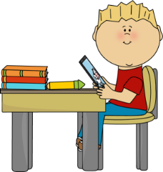
Study Space
Young people do benefit from having a small space to study with an area they can work on with a good light. If they can have access to the internet that will also be beneficial but all advice is that this should be in a public area of the home rather than their bedroom. If they are aware that you are around they are less likely to be drawn into behaviour that is risky or dangerous. The following website gives useful advice to parents and carers about how to keep their children safe on line. https://www.thinkuknow.co.uk/parents/

There are also videos about other internet safety matters. This one by the BBC is very good.
http://www.bbc.co.uk/webwise/0/21259413

Internet safety is also covered in ICT lessons in S1.
Extra-Curricular Activities
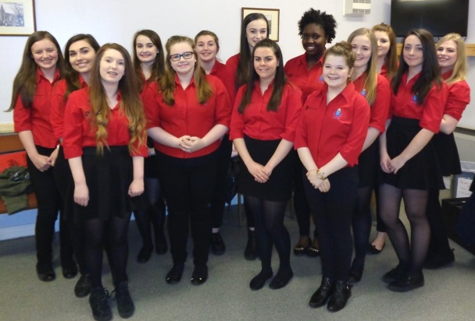
When you encourage your child to get involved in activities beyond the classroom you are supporting their development of many skills. They will learn lots by being part of groups and organisations that encourage them to push themselves, to be resilient and to learn new skills. Young people benefit from the social aspects of such groups too – they learn how to get on with people they don’t know well, how to work with adults in authority and when they achieve success it boosts their confidence. If young people participate in an activity over a long period of time it demonstrates perseverance and an ability to apply yourself to something that takes effort. These are qualities and skills valued in the workplace. It can be tricky when young people want to give up an activity and it is perfectly normal for them to try out lots of different things as they are growing up. The important thing is to get involved and to have activities for the evenings and weekends that get them out and about and making new friends to broaden their horizons. This will support their mental health as well as their physical health.

We offer a number of extra-curricular activities in school – at lunch times and after school. It can be difficult to fit lifts in when you are working but perhaps a number of parents can get together to share the burden. Please don’t let finance be a barrier to participation. Our school fund is there to support young people who have to travel to events, need help with fees or who just need a little bit more support.

What’s going on in school?
The school website is a great source of information. We often send a text message home to alert you to useful information or letters that have been issued so that you do not just have to rely on bag mail.

Attendance
Young people who attend school regularly will achieve more than those who do not. We aim for 100% attendance for all our young people but of course they do get sick. The procedure for reporting this is detailed in the school prospectus. We don’t want you to send your son/daughter to school if they are too ill to learn but a cold or a general feeling of being unwell can often be worked through. Again eating well, getting enough sleep and drinking plenty water can make a huge difference to how we all feel

Please don’t be alarmed if your son/daughter is reported as absent and you have sent them to school that morning. We try hard to make sure absence information is accurate but sometimes mistakes are made. If you get an alert please phone the school and we will double check. It can be a bit worrying but we would rather report a child as absent to a parent and find it is a mistake than the other way around.
What are we trying to achieve?
Our school aims and values really sum up what we are trying to do with and for the young people of Bridge of Don Academy. We want all young people to become:

- Successful learners
- Confident Individuals
- Responsible Citizens
- Effective contributors

We believe that they will achieve these aims if, with your support, they try really hard to:

- Be honest
- Be caring
- Be respectful
- Be your best

Further Reading:
The following are useful sources of information:
School website – www.bridgeofdon.aberdeen.sch.uk

School Facebook Page – Bridge of Don Academy Official – this is linked to our school website.

Scottish Qualifications Authority – source of information about the exams www.sqa.org

NPFS - National Parent Forum of Scotland has produced Revision in a Nutshell guides for the new Highers (20 subjects) and updated Revision guides for National 5s (20 subjects). These revision guides contain direct links to SQA specimen question papers, exemplar question papers plus past question papers, where appropriate. The guides advise learners to check with their teachers to make sure that material is relevant. The guides are primarily intended to provide the SQA direct links by subject in one place, and to give some additional revision opportunities.

http://www.npfs.org.uk/new-higher-revision-guides/

http://www.npfs.org.uk/national-5-revision-in-a-nutshell/

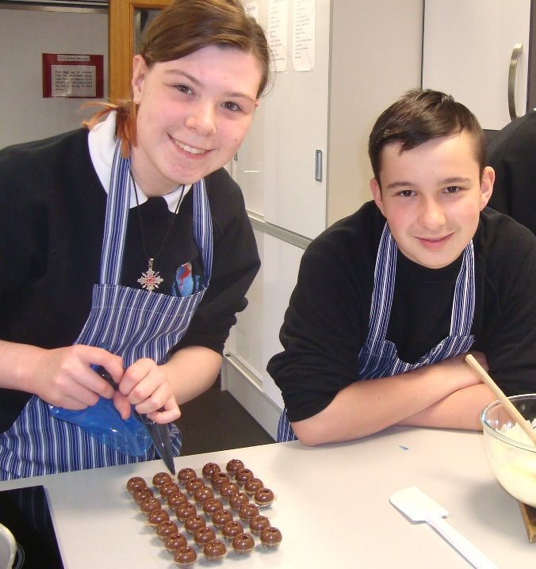

S2 Leadership Day

http://www.brainyquote.com/quotes/quotes/m/michaeljor127660.html#Cgreh7LXbdafGcWs.99

