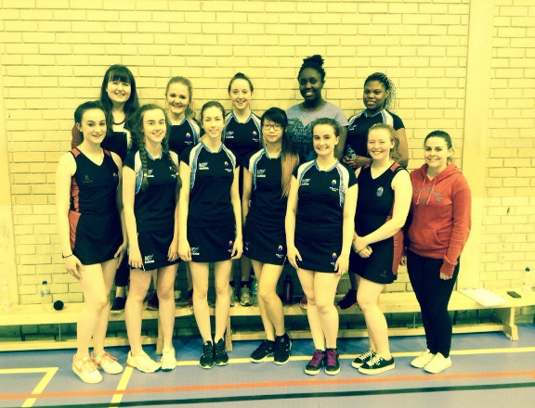
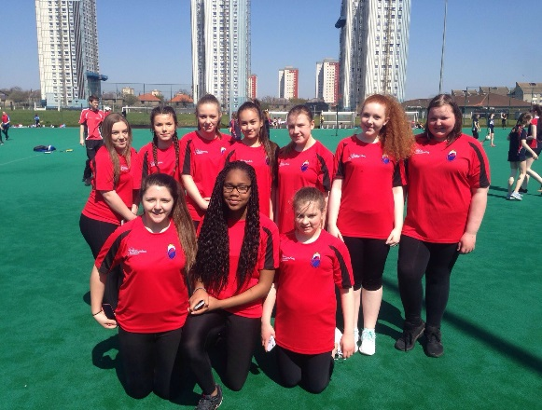
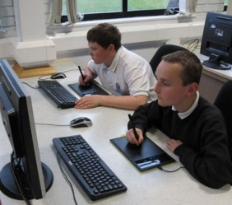
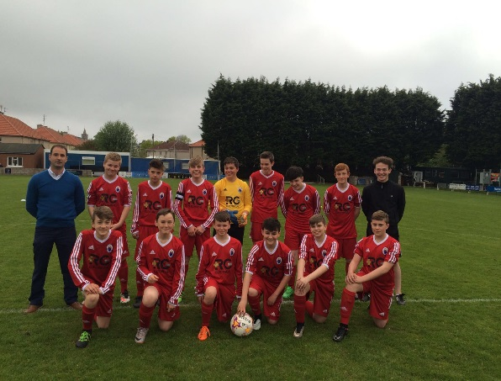
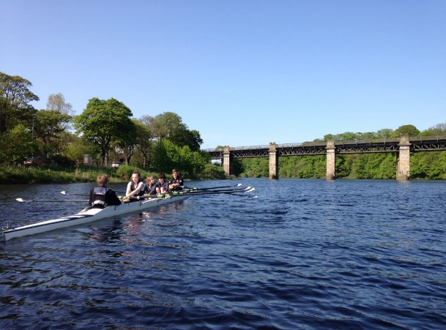
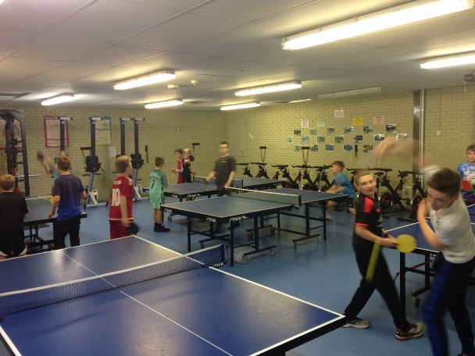
BRIDGE OF DON ACADEMY
Extra Curricular 2016-2017

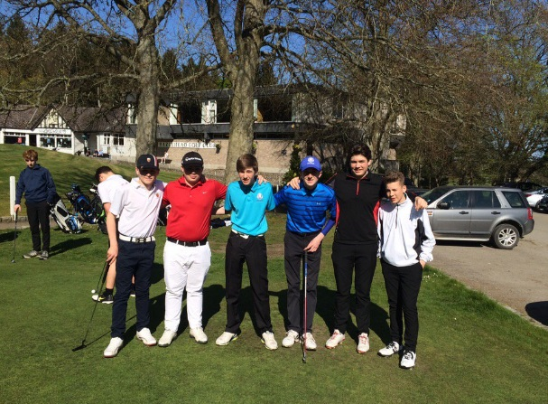
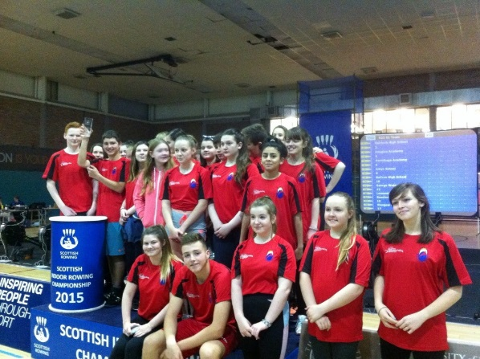
ACTIVITY VENUE TIME PEOPLE RESPONSIBLE
MONDAY
Lunch Time Activities
Homework Club F20 1.20 – 1.50 Mrs Wood
Volleyball Games Hall 1.20 – 1.50 Mr Jappy
Senior Strength and Conditioning Activities Room 1.20 – 1.50 Mr Wallace

After School Activities
Staff Fitness Games Hall 4.15 – 5.00 PE Department

TUESDAY
Lunch Time Activities
Homework Club F20 1.20 – 1.50 Mrs Wood
Art Catch Up Club Art Department 1.05 – 1.50 Mrs Redpath
Youth Alpha Film Series G3 (Technical) 1.15 – 1.45 Miss Fitzpatrick
Global Goals Group G12 1.15 – 1.50 Mrs Walkden
Table Tennis Activities Room 1.20 – 1.50 Mr Jappy
Play Unified Club Games Hall 1.20 – 1.50 Stacey J. & PE Department
Badminton Games Hall 1.20 – 1.50 Mr Wallace

After School Activities
Basketball (S1-6) Games Hall 4.00 – 5.00 Shannon M. and Miss Guthrie

WEDNESDAY
Lunch Time Activities
Homework Club F20 1.20 – 1.50 Mrs Wood
S1/S2 Drama Club Drama Studio 1.25 – 1.50 Miss James
Dance Activities Room 1.20 – 1.50 Cassandra W., Simone T.
and Miss Davidson
Gymnastics Games Hall 1.20 – 1.50 Stacey J. and Miss Malone

After School Activities
Girls Football Outside 3.00 – 4.00 Miss Malone

THURSDAY
Lunch Time Activities
Homework Club F20 1.20 – 1.50 Mrs Wood
Photoshop Club G3 (D&T Computer Suite) 1.05 – 1.50 Mrs Redpath
Pi / Maths Club F9 1.30 – 1.50 Mr Willox
Chemistry Lunch Club T13 1.05 – 1.50 Miss A. Davidson
Tennis Games Hall 1.20 – 1.50 Charlie C. and Mrs Walkden
Boys’ Only Fitness Activities Room 1.20 – 1.50 David T. and Mr Wallace

After School Activities

FRIDAY
Morning
Homework Club F20 1.20 – 1.50 Mrs Wood

Lunch Time Activities
Chess Club T13 1.20 – 1.50 Miss A. Davidson
S1/2 Indoor Football Games Hall 1.20 – 1.50 Bradley P. and Mr Donald
Girls Only Session Activities Room 1.20 – 1.50 April M. and Miss Malone

After School Activities
S1-S6 Netball Games Hall 3.00 – 4.00 Active Schools
Debating Club T20 3.00 – 4.30 Amber T. & Mr Warrender

Further Opportunities
Young Enterprise As arranged Mrs McWilliam (Biology)
Student Council As arranged Miss Davidson, Mrs Walkden and Mrs Constable
Sports Coaching (volunteering) PE Department As arranged Active Schools/PE Department
Sky Sports Living for Sports PE Department As arranged PE Department
Sports Council PE Department As arranged Sam (Active Schools)
Fit 4 Girls PE Department As arranged PE Department
Golf Team PE Department Easter 2017 Mr Jappy
U13s/S1 Football Team PE Department As arranged Sam M. and Mr Donald
U14s/S2 Football Team PE Department As arranged Kelvin M. and Mr Donald
U15s/S3 Football Team PE Department As arranged Bradley P. and Mr Jappy
Senior (S4-S6) Football Team PE Department As arranged Liam D. and Mr Wallace

